
Pet Registration
Revision:0.2



Table of Contents
S.No | Topics | Page No
Document
1. | Introduction | 3
2. | Purpose | 3
3. | System Overview | 3
4. | Software Development Tool | 4
5. | Database Structure | 5
 | 5.1 Registration Details | 5
 | 5.2 Login details | 6
 | 5.3 User Module | 6
 | 5.4 Veterinary Officer | 8
 | 5.5 Payment process | 9
 | 5.6 SMS Sender | 9
 | 5.7 Administrator | 10

Document
Document History
Version # | Date | Authors | Comments
0.1 | 04.08.2023 | Ramya | Created document

1. Introduction
This document explains the technical specifications and requirements for Pet Registration.
At present, Greater Chennai Corporation is providing various online services and one of the services is pet registration in which people (Owners) can register their pet animals in web-portal to obtain a valid pet licence. The purpose of the online pet license system launched by Chennai Corporation is to streamline and regulate pet ownership within the city. It aims to ensure responsible pet ownership, maintain a database of registered pets, and enforce relevant rules and regulations. The online system allows pet owners to apply for and obtain licenses for their pets, facilitating better management of pet-related issues such as vaccinations, health records, and identifying lost or stray pets.
2. Purpose
This document will be used in solution development and maintenance. It contains the technical specification that shall be respected by the developer during the development. For maintainer it serves as a guide to a better understanding of the architecture and the scope of the solution.
3. System Overview
This section introduces the context and design of the system. This application has three modules.
- User
- Veterinary Officer
- Admin
The diagram below explains the main components of the Web-Portal for Pet registration.
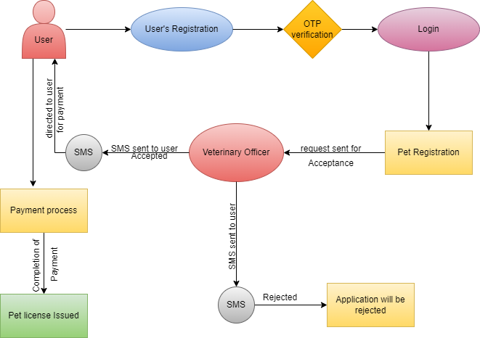
4. Software Development Tool
The decision about software development tools is completely up to the developer. The Investor has no particular preferences in this respect as long as development tools enable a full functionality of the web-tool according to main user requirements.
Development Tools: -
- Eclipse IDE.
- MySQL version 8.0
External jars: -
    - Spring boot Framework.
    - Thyme leaf.
    - MySQL. Connector.
    - razor pay-java (Version:1.4.3)
    - Spring-data-JPA

Database Structure
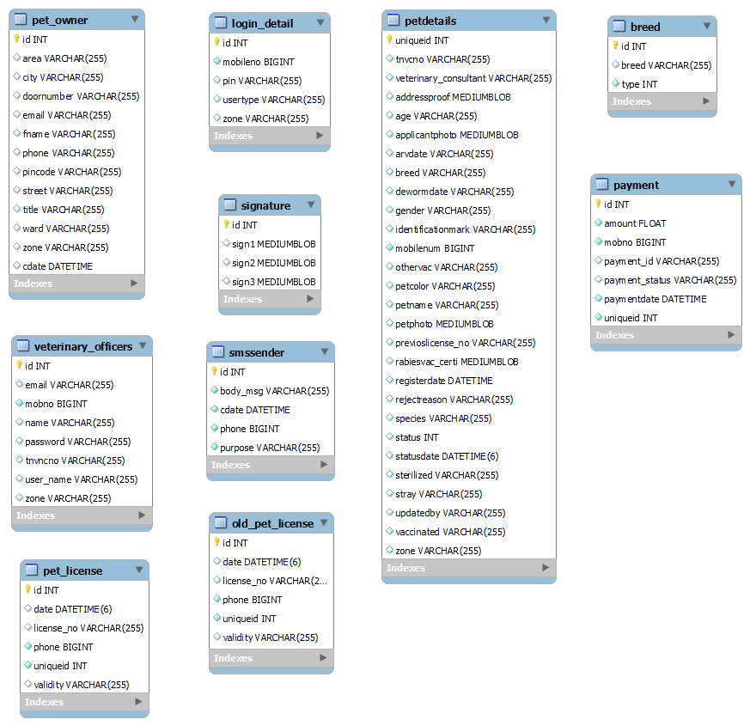

  - Registration Details
The application will allow for creation of new users in this system. The user should able to apply for pet license only if they became a registered user of this application. To be a registered user, the user should provide the following details.
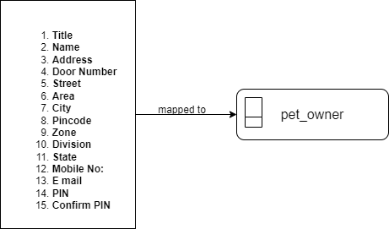

5.2 Login details
For login process, it involves the following.
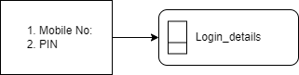
The user should give their registered Mobile number and PIN while logging in. Based on the Mobile Number, the user type will be detected and directed to that page.
5.3 User Module
Once the user (Owner) registration was done, the user (owner) page was created and has a following access.
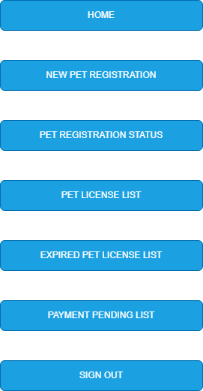

After creating a new user login, the owner of the pets need to provide the details of their pets for further process by clicking “New Pet Registration”. The details to apply for pet license are includes the following.
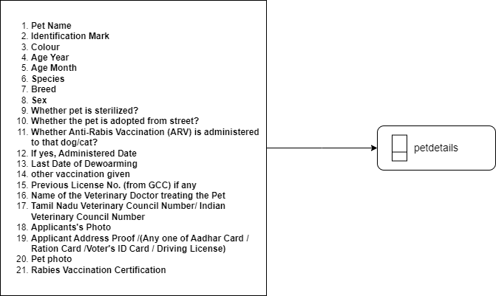
5.4 Veterinary Officer
The system is dually managed by the Administrator. After completion of Application for pet license request from user side, the application will be directed to Veterinary Officer for acceptance. Veterinary Officer login will be created by Administrator.
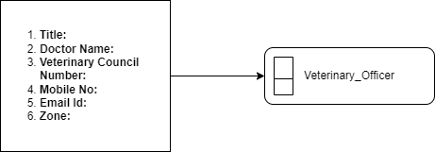
For each Zones, limited to Greater Chennai Corporation One Veterinary Officer will be assigned and the application will be directed to that particular Veterinary Officer at that particular Zone. Each Veterinary Officer has the access to accept or reject the application at that particular zone of Greater Chennai Corporation.
Veterinary Officer
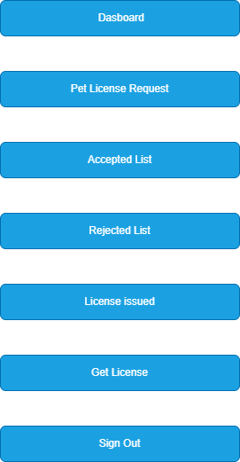

Veterinary Officer will verify all the information and documents submitted by the user for pet license and will updated the status.
- If the application is accepted by the Veterinary Officer the application will be redirected to user side for payment process.
- If the application is rejected by the Veterinary Officer the application will be cancelled and the reason for cancellation will be updated.
5.5 Payment process
After the acceptance of request by Veterinary Officer for pet license, Payment should be carried for issuance of Pet License. The status will be updated to user (Owner) via SMS as well as in user’s page. The payment will be made only through Online Payment Gateway: - RazorPay
Once payment was completed the following details will be created. User can download the pet license from “Pet License List”.
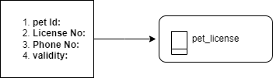

5.6 SMS Sender
SMS will be sent to the user’s registered mobile number at several stages.
- For registration - Once the user entered the required details OTP (One Time Password) will be sent the registered mobile number.
- For forget password – If user request for forget password OTP will be sent to the registered mobile number.
- For Acceptance – If veterinary officer has accepted the owner’s Application for pet license request.
- For Rejection – If veterinary officer rejects the owner’s Application for pet license request, SMS containing the reason for rejection will be sent.
- SMS Gateway URL: - https://api.onex-aura.com/api/sms
5.7 Administrator
The system is dually managed by the Administrator. Veterinary Officer login will be created by Administrator. The Administrator has the provision to accept or reject the application from all zones of Greater Chennai Corporation. Administrator has the access to create the category of the Breed of each Species.
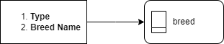
Admin Login
