COWORKSPACE DOCUMENT
Prepared Date:25-08-2026
The application consists of 16 buildings with the following categories:

- Desk Space
- Learning Centre
- Meeting Rooms

DATABASE / SCHEMA DETAILS
Schema Name: coworkingspace
Database:MySQL
TABLES
1. absent_count
2. amenities
3. amount_config
4. attendance
5. booking
6. buildings
7. calendar
8. category
9. category_images
10. checklist_feedback
11. complaint_details
12. complaint_details_history
13. login
14. marquee
15. options_values
16. order_log
17. payment
18. payment_master
19. question_master
20. refund_info
21. refund_info_copy
22. review
23. shift_master
25: slots
26: subcategory
27: temp_booking

workspacelist page:
API: /muthalvarpadaippagam/api/details
Method:GET
Table: buildings,Categoty, subcategory
Purpose:
This API fetches the building details from the database.
Response Data:
The API returns the following details for each building/category:
bid → Building ID
name → Building / Coworking Space Name
district → District name
pincode → Pincode
area → Area
cid → Category ID
display_name → Category display name
building_image_url → Building image URL
address → Building address
Usage:
The frontend calls this API to fetch building details. The returned bid and cid are used to identify the selected building and coworking category.
Screenshot:
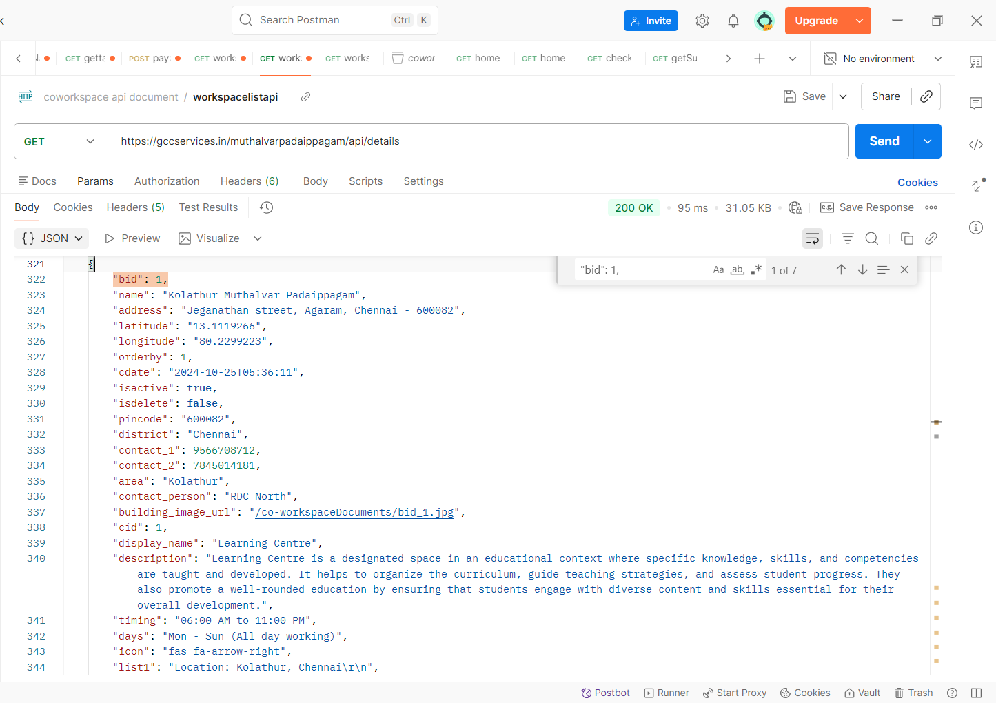

API 2: Marquee Message
API: /muthalvarpadaippagam/book/api/marquee
Method:GET
Table: marquee
Purpose:
This API provides the notification/marquee message displayed on the page.
Response Data:
Unoccupied Desk Space Booking slots will open daily after 11:00 AM for the particular day.

Frontend Behavior:
The message is displayed in a scrollable marquee section on the page.
Usage: When users open the booking page, this message informs them that the unoccupied desk-space booking slots for the particular day will become available after 11:00 AM.
Screenshot:
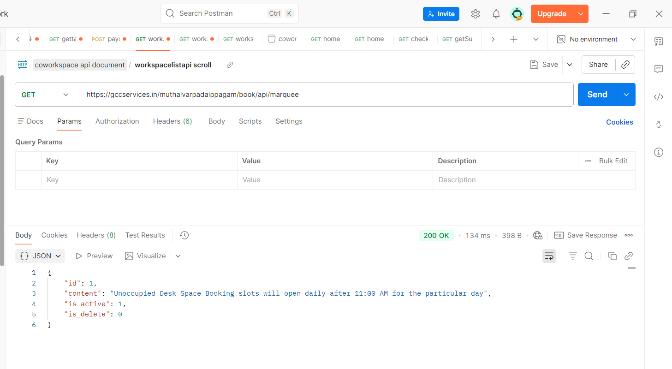

API 3: Google Reviews
API:/muthalvarpadaippagam/book/api/reviews
Method:GET
Table: review
Purpose:
This API provides Google review information that is displayed on the page.
Data Source:
Database
The frontend does not directly fetch reviews from the Google API.
A scheduler runs every day at 1:00 AM and checks for new Google reviews.

Duplicate Check:
The scheduler checks the review's:
author_name
review time
If the name and time already exist in the database:
Review already exists
→ Do not insert
If the review is new:
New review
→ Insert into database
This prevents the same Google review from being inserted multiple times.
Screenshot:
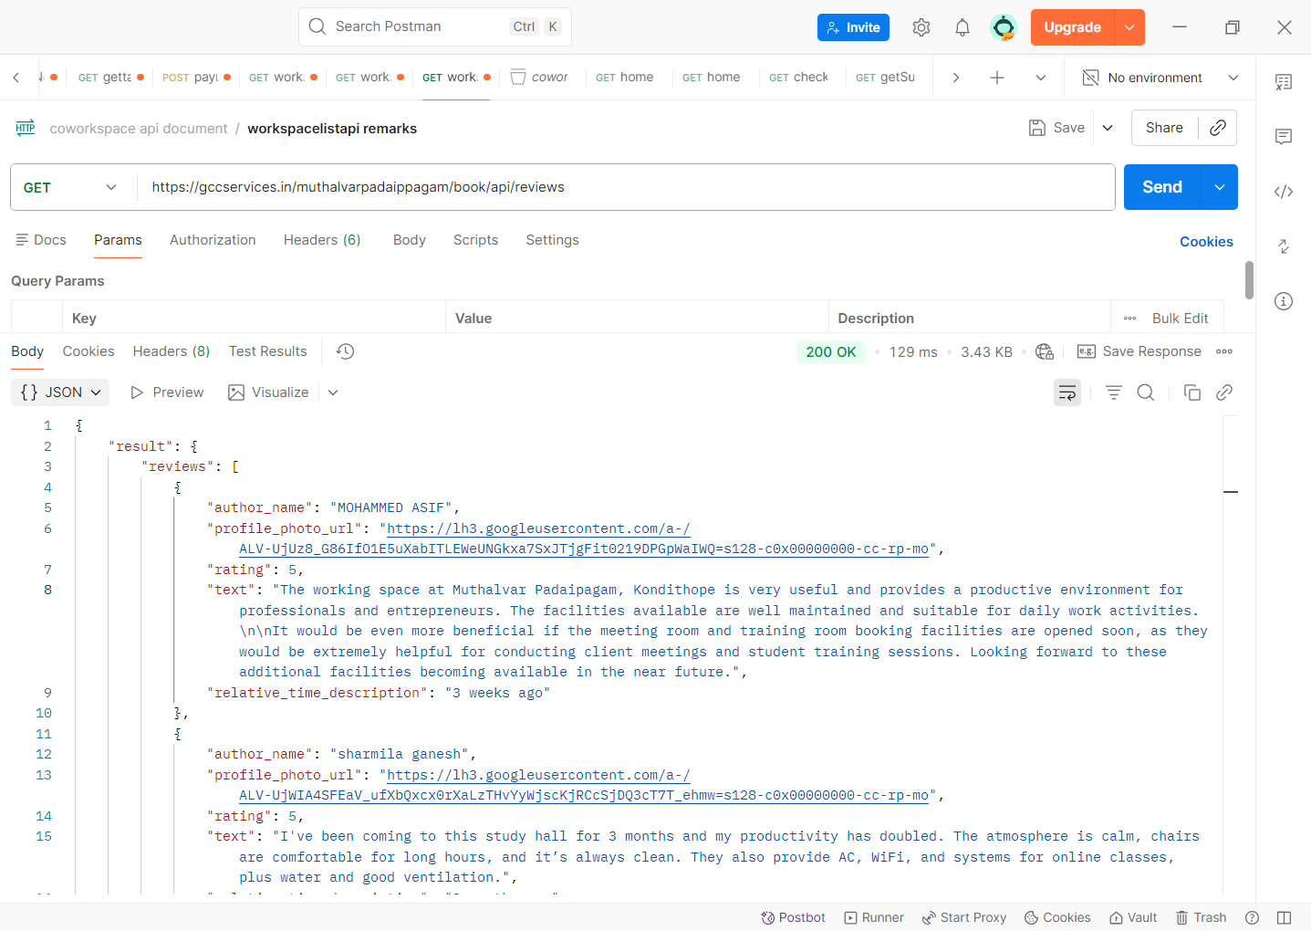

API Response Data
The API returns a result containing:
Review Details
Each review contains:
profile_photo_url-> Profile Photo
author_name-> Reviewer Name
relative_time_description->time
rating->Star Rating
text-> Review Text

HOME PAGE:
API: /muthalvarpadaippagam/api/pricing?cid=${cid}
Method: GET
Table: category, subcategory
Purpose:
This API fetches the pricing and subcategory details based on the selected workspace.
Request Parameter:
cid → Category ID
Response Data:
The API returns the following pricing/subcategory details:
display_name → Pricing / Subcategory Name
capacity → Capacity of the particular pricing/subcategory
scid → Subcategory ID
Usage:
The frontend calls this API with the selected cid to fetch the pricing details. The returned data is used to display the pricing cards for Desk Space, Meeting Rooms and Learning Centre.

Screenshot:
success:
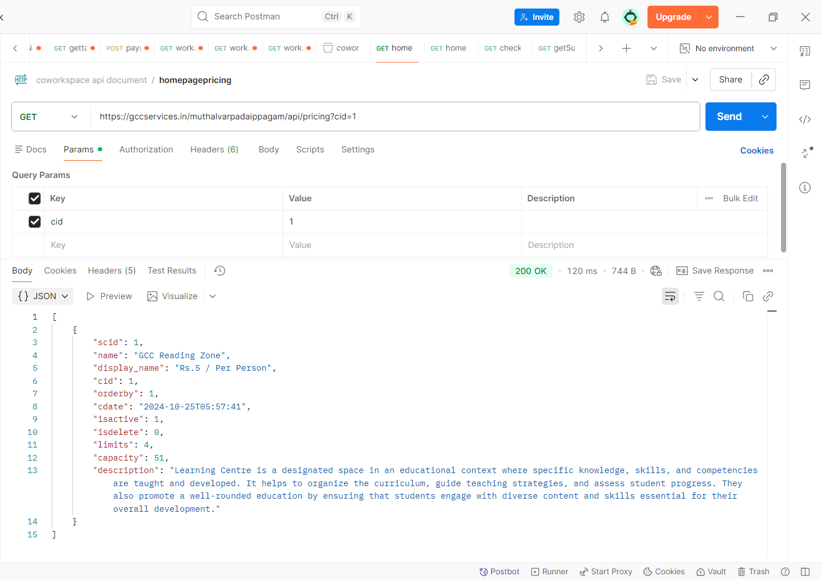
failure:
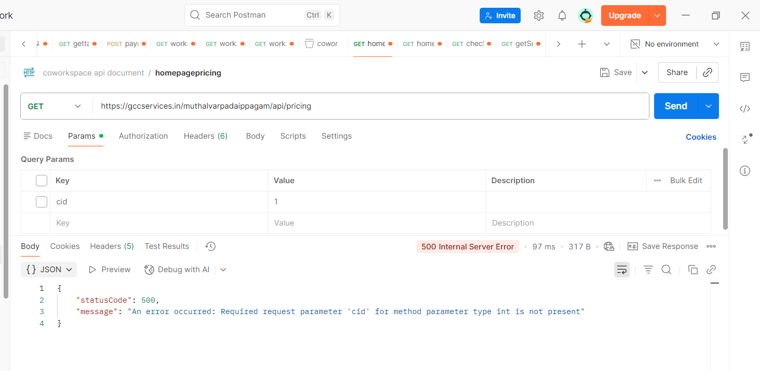

-----------------------------------------------------
API: /muthalvarpadaippagam/book/api/marquee
Reference:
This API is already used in the Workspace List page. Please refer to the **Workspace List Page – Marquee API** for the API details.
API: /muthalvarpadaippagam/book/api/reviews
Reference:
This API is already used in the Workspace List page. Please refer to the **Workspace List Page – Google Reviews API** for the API details.
----------------
API: /muthalvarpadaippagam/home/space
Method: GET
Table: category, category_images, subcategory
Parameters:
cid → Category ID
bid → Building ID
Purpose:
This API fetches the selected coworking space details for the selected building and category.
Action:
The frontend calls this API when the user clicks a coworking space/category tab.
The API:
- Fetches the active coworking spaces for the selected building.
- Finds the selected category using cid.
- Sends the selected workspace details to the Thymeleaf fragment.
- Returns only the workspace content instead of reloading the complete Home page.
Response Data:
The selected workspace details include:
display_name → Workspace / Category display name
imageurl → Workspace image
description → Workspace description
list1 → Feature / information 1
list2 → Feature / information 2
list3 → Feature / information 3
bid → Building ID
cid → Category ID
scid → Subcategory ID
Response:
Returns the Thymeleaf fragment:
fragments/spaceContent :: content
Usage:
The frontend receives the returned HTML and replaces the #space-content section with the selected workspace details.
The Book Now button uses the selected bid, cid, and scid to proceed to the booking page.
Note:
This API is used for dynamically changing the workspace content on the Home page without refreshing the entire page.

Screenshot:
Success: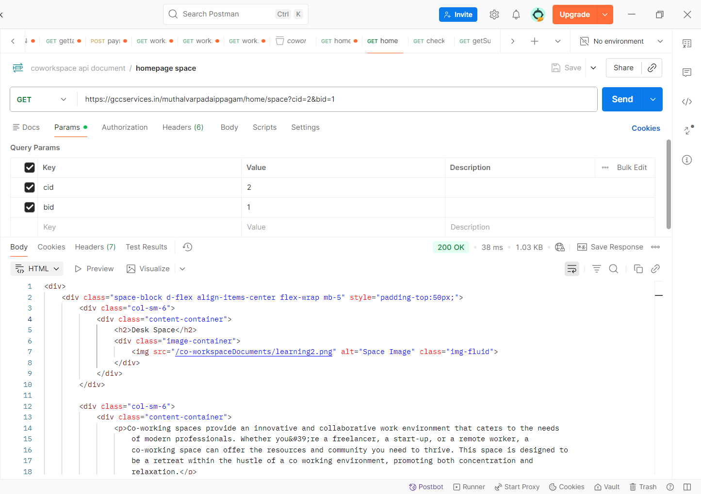

Failure:
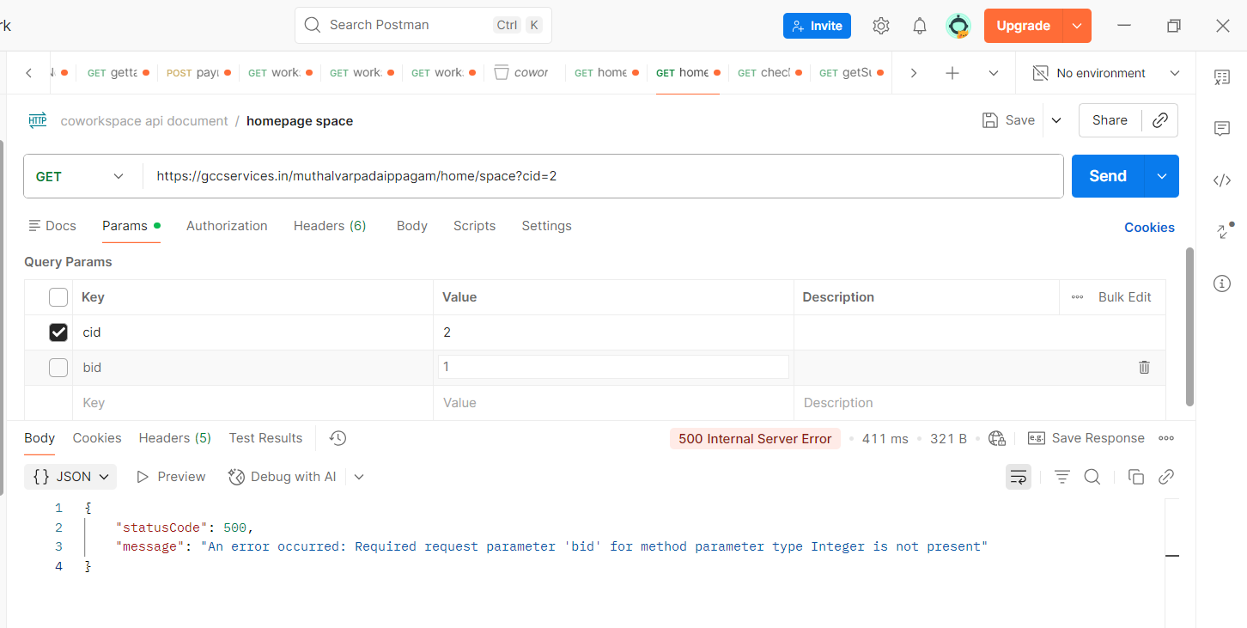
Workdesk
API: /muthalvarpadaippagam/book/api/checkAvailslots
Method: GET
Table: calendar
Parameters:
bid → Building ID
cid → Category ID
bDate → Boo king Date
scid → Subcategory ID
slotId → Slot ID

Purpose:
This API checks the seat availability for the selected building, category, booking date, subcategory and time slot.

Action:
The API receives the selected booking details and checks the availability of seats for the selected date and time slot.

Response:
The API returns the number of available seats for the selected date and time slot.

Example:38

Here, `38` indicates that 38 seats are available.

Usage:
The frontend calls this API when the user selects a time slot.
The returned available seat count is displayed on the booking page.
If the response is `0`, the frontend displays:"Slot Full". and the user is not allowed to proceed with the booking.
Screenshot:
Success:
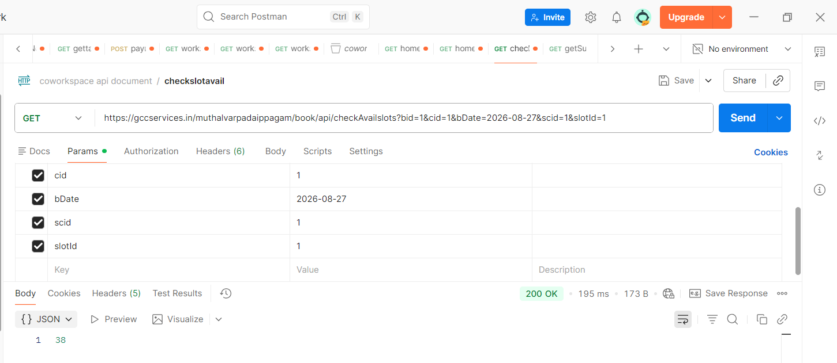

Failure:
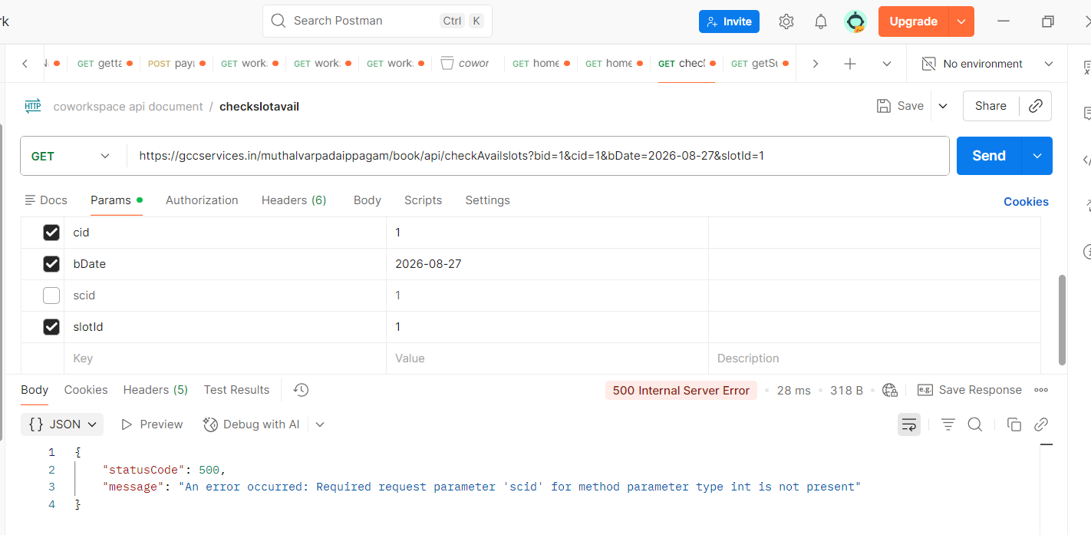

API: /muthalvarpadaippagam/api/getSubCategoryByCid
Method: GET
Table: subcategory
Parameters:
cid → Category ID
Purpose:
This API fetches the subcategory details for the selected category.
Action:
The API receives the cid and retrieves the corresponding subcategory records from the subcategory table.
Response Data:
The API returns the subcategory details, including:
scid → Subcategory ID
Usage:
The frontend calls this API when the booking page is loaded to get the subcategories available for the selected category.
The returned display_name is checked to identify the booking type:
- If display_name contains "half", the returned scid is assigned to the Half Day option.
- If display_name contains "full", the returned scid is assigned to the Full Day option.
- If display_name contains "month", the returned scid is assigned to the Month option.
The assigned scid is then used for subsequent booking and availability API calls.
Screenshot:
Success:
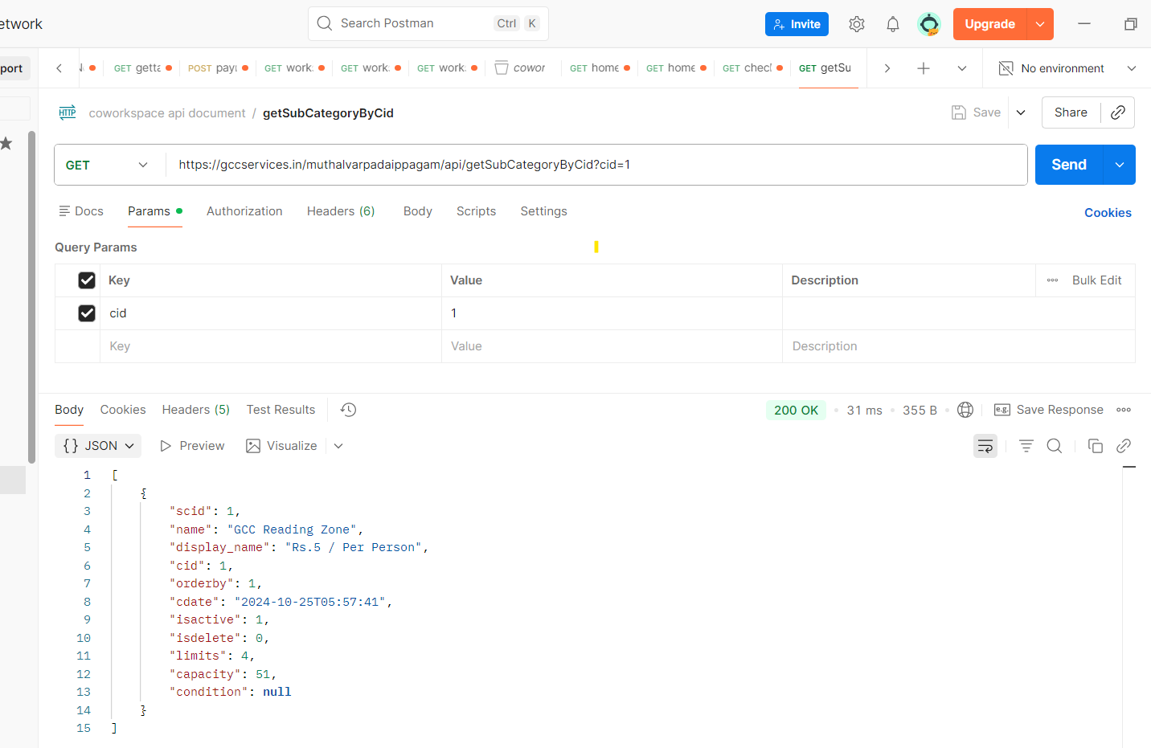
Failure:
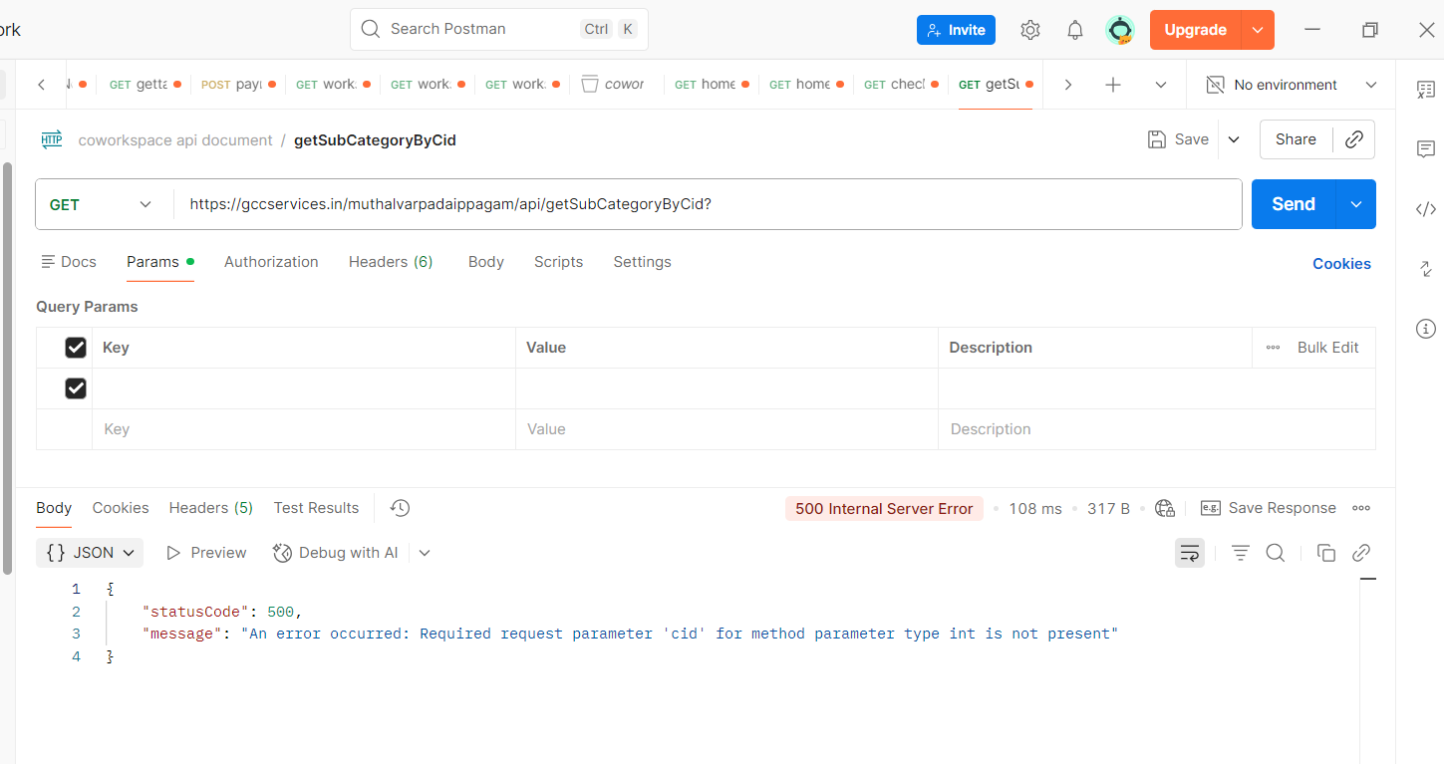
API: /muthalvarpadaippagam/api/getSlotBySid
Method: GET
Table: slots
Parameters:
scid → Subcategory ID
Purpose:
This API fetches the available time slots for the selected subcategory type.
Action:
The API receives the selected scid and retrieves the active time slots associated with that subcategory from the slots table.
Response Data:
The API returns the available slot details, including:
slotid → Slot ID
scid → Subcategory ID
name → Time slot name(09:00 AM to 03.00 PM)
start_time → Slot start time
end_time → Slot end time
Usage:
The frontend calls this API when the user selects the booking type such as Half Day, Full Day or Month.
The returned slots are displayed under Available Time Slot on the booking page.

API: /muthalvarpadaippagam/book/api/saveInTemp
Method: POST
Table: temp_booking
Parameters:
catId → Category ID
buildId → Building ID
subId → Subcategory ID
noOfPeople → Number of people/seats required
fromDate → Booking start date
toDate → Booking end date
userName → User name
userMobile → User mobile number
slots → Selected slot IDs
Purpose:
This API temporarily saves the user's booking details before proceeding to the payment process.
Action:
The API receives the selected booking details and performs the following actions:
- Checks whether the selected building is available for the selected category and subcategory.
- Checks the selected booking dates and slots for availability.
- Gets the configured amount for the selected slots.
- Calculates the booking amount based on the selected slots and number of people.
- Saves the booking details temporarily in the temp_booking table.
- Generates a temporary booking ID (tempBookId).
- Returns the temporary booking details along with the calculated amount.
Response Data:
The API returns:
tempBookId → Temporary booking ID
userName → User name
userMobile → User mobile number
slotIds → Selected slot IDs
fromDate → Booking start date
toDate → Booking end date
noOfPeople → Number of people/seats
catId → Category ID
buildId → Building ID
subId → Subcategory ID
amount → Total booking amount
Usage:
The frontend calls this API when the user clicks Book Now after selecting the required booking details.
The returned tempBookId and amount are used to display the booking confirmation/payment modal.
The Pay Now button is then generated using the temporary booking ID and final amount.
Screenshot:
Success:
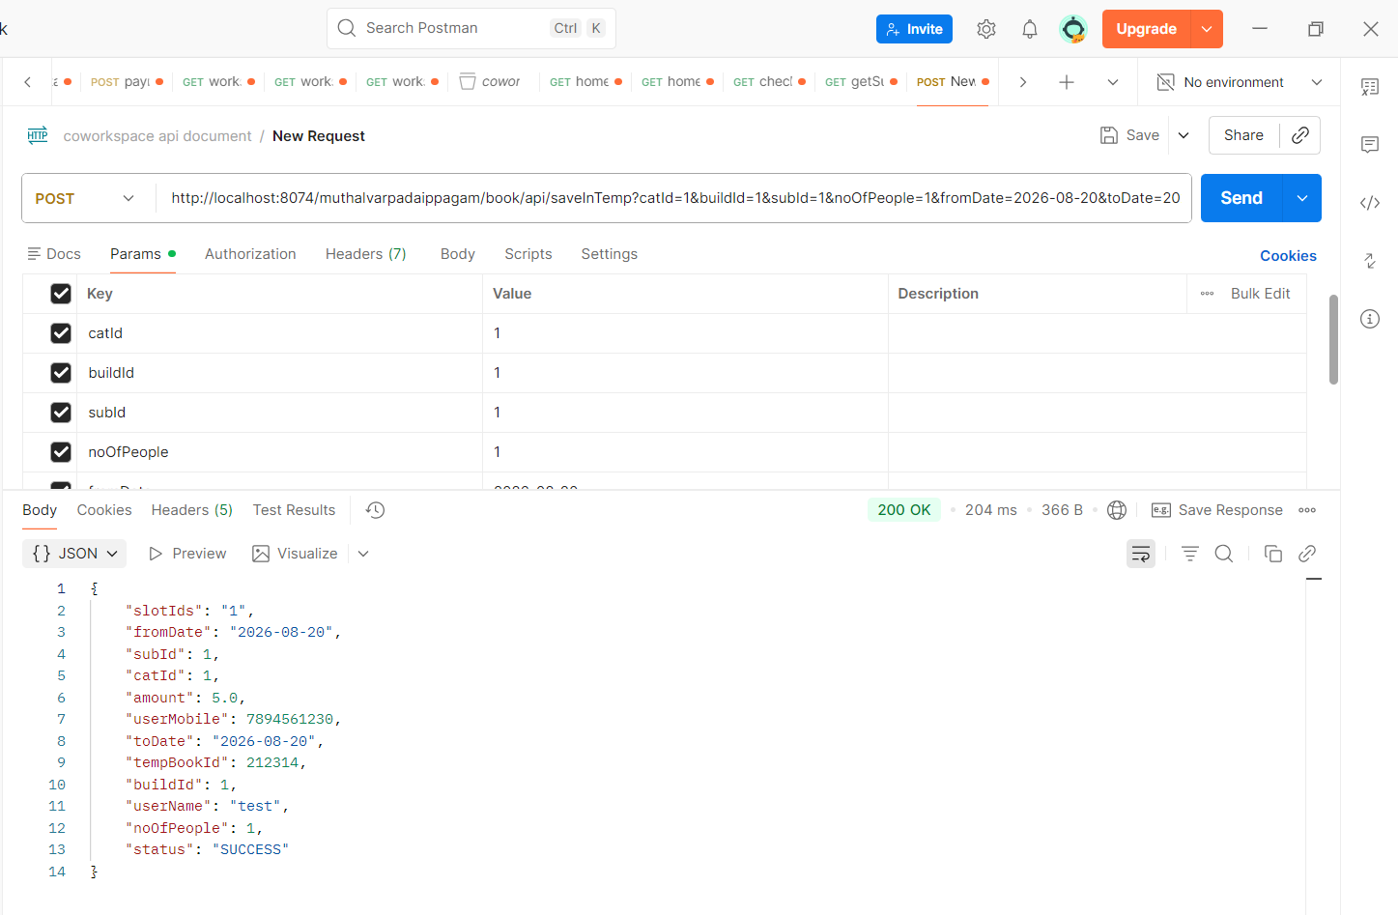

Failure:
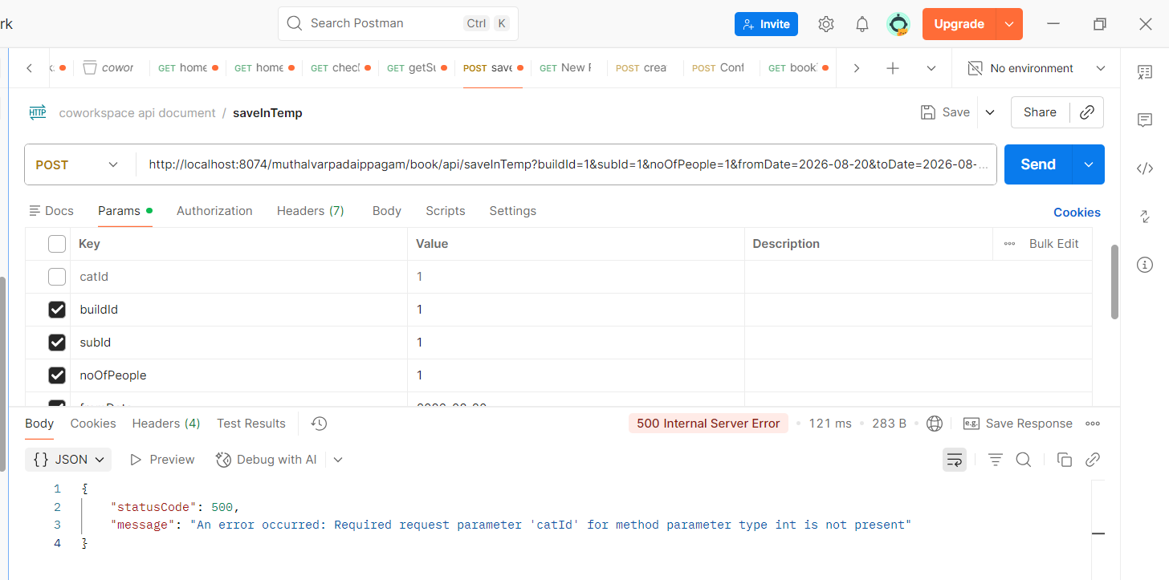
-----------------------------------
API: /muthalvarpadaippagam/book/api/create_order
Method: POST
Table: order_log
Parameters:
id → Temporary Booking ID
Purpose:
This API creates and stores the order information associated with the temporary booking before proceeding with the payment process.
Action:
The API receives the temporary booking ID and uses it to create an order record. The order details are stored in the order_log table.
The order log stores:
order_id → Order ID
order_info → Order information
temp_booking_id → Temporary booking ID
Response:
The database operation returns the generated id of the newly inserted order log record.
Usage:
The frontend calls this API as part of the payment/order creation process using the temporary booking ID.
The generated order log ID is used for further processing of the booking/payment flow.
Screenshot:
Success:
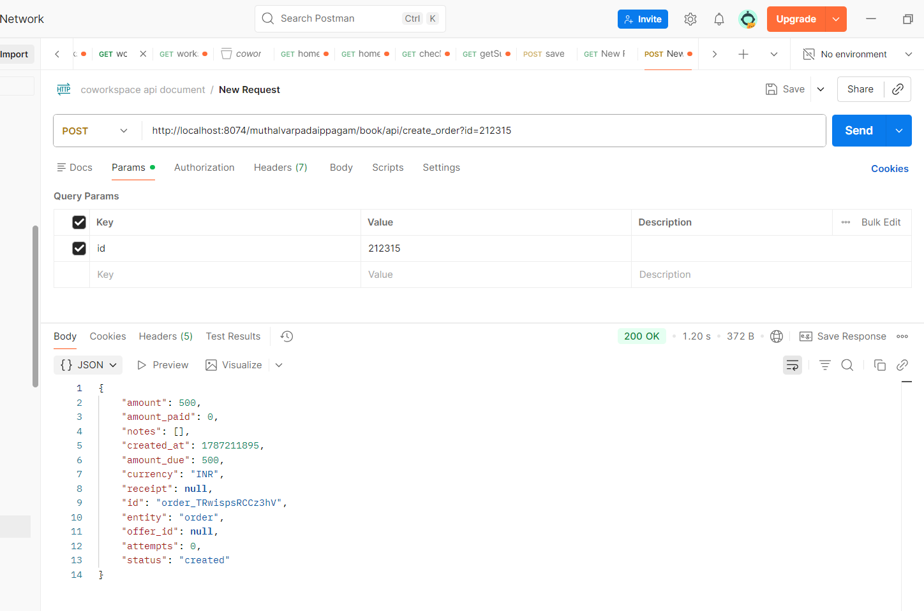

Failure:
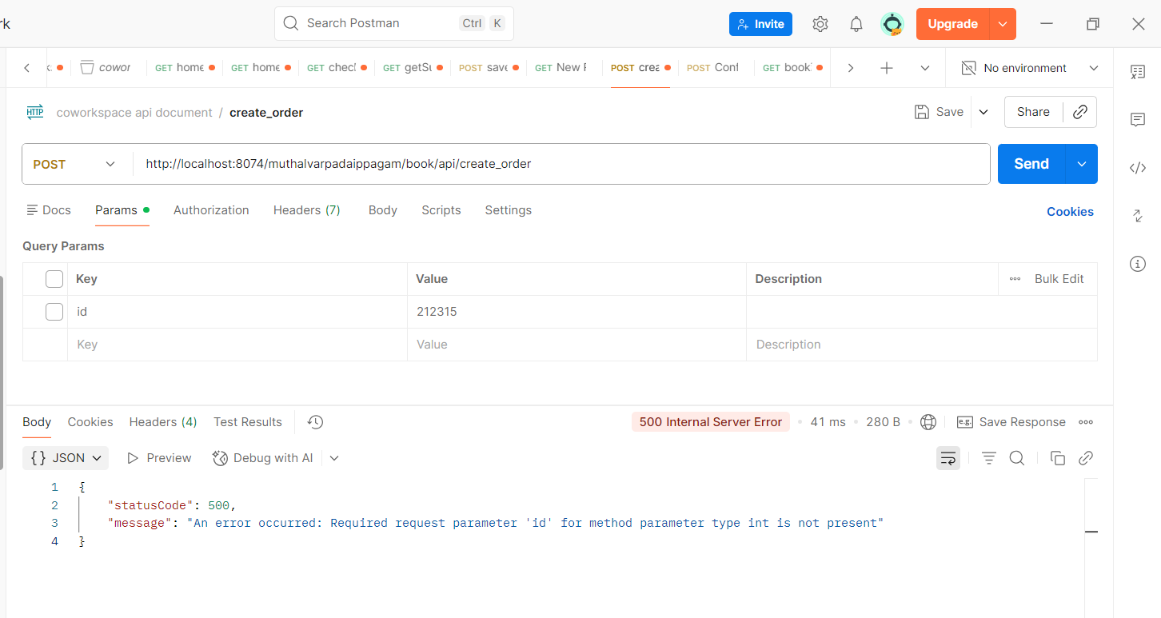
------------------------------------
API: /muthalvarpadaippagam/book/api/Confirm
Method: POST
Table: payment, booking, calendar
Parameters:
payment_id → Payment ID
order_id → Payment Order ID
status → Payment status
id → Temporary Booking ID
amount → Payment amount
Purpose:
This API confirms the payment details and creates the final booking after successful payment.
Action:
The API receives the payment information and temporary booking ID.
It saves the payment details in the payment table and creates the final booking using the details stored in the temporary booking.
After the booking is created:
- Payment record is updated with the generated booking ID.
- Booking details are added to the calendar.
- Booking confirmation message is sent.
- A booking ID is generated and returned to the frontend.
Response:
The API returns the generated booking ID when the booking is successfully created.
Screenshot:
Success:
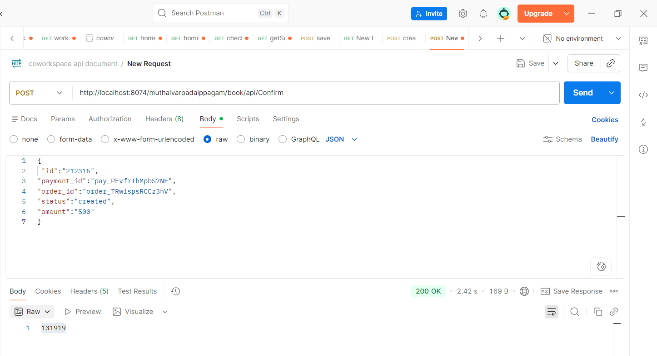
-----------------------------------------------
API: /muthalvarpadaippagam/bookingQRCode?booking_id=${booking_id}
Method: GET
Table: booking, buildings, slots, category
Parameters:
booking_id → Booking ID
Purpose:
This API/page fetches the booking details for the generated booking ID and displays them in the Acknowledgment / QR page.
Action:
The API receives the booking ID and fetches the corresponding booking information from the database.
The booking information is combined with:
- Building details
- Slot details
- Category details
- Booking dates
- Payment details
- Booking status
Response Data:
The booking acknowledgment displays the following details:
booking_id → Booking ID
user_name → User name
mobile → User mobile number
buildingname → Building name
buildingaddress → Building address
from_date → Booking start date
to_date → Booking end date
cdate → Booking creation date
amount → Booking amount
payment_status → Payment status
no_of_person → Number of persons/seats
slotids → Selected slot IDs
duration → Selected time slot
type → Booking category
type_name → Category display name
checkin → Check-in time
checkout → Check-out time
duration_hours → Duration in hours
booking_status → Booking status
calculated_status → Current booking status
Usage:
After successful payment and booking creation, the frontend redirects the user to this page using the generated booking_id.
The fetched booking details are then displayed in the Acknowledgment format, along with the booking/QR information.
Screenshot:
Success:
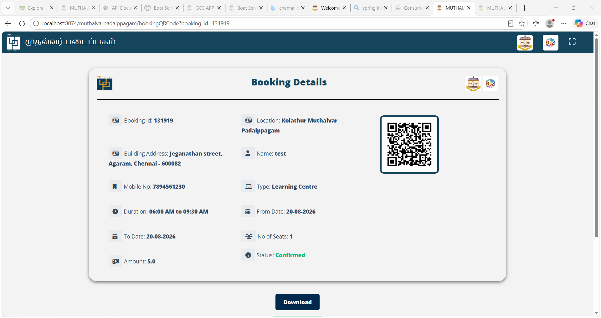
Failure:
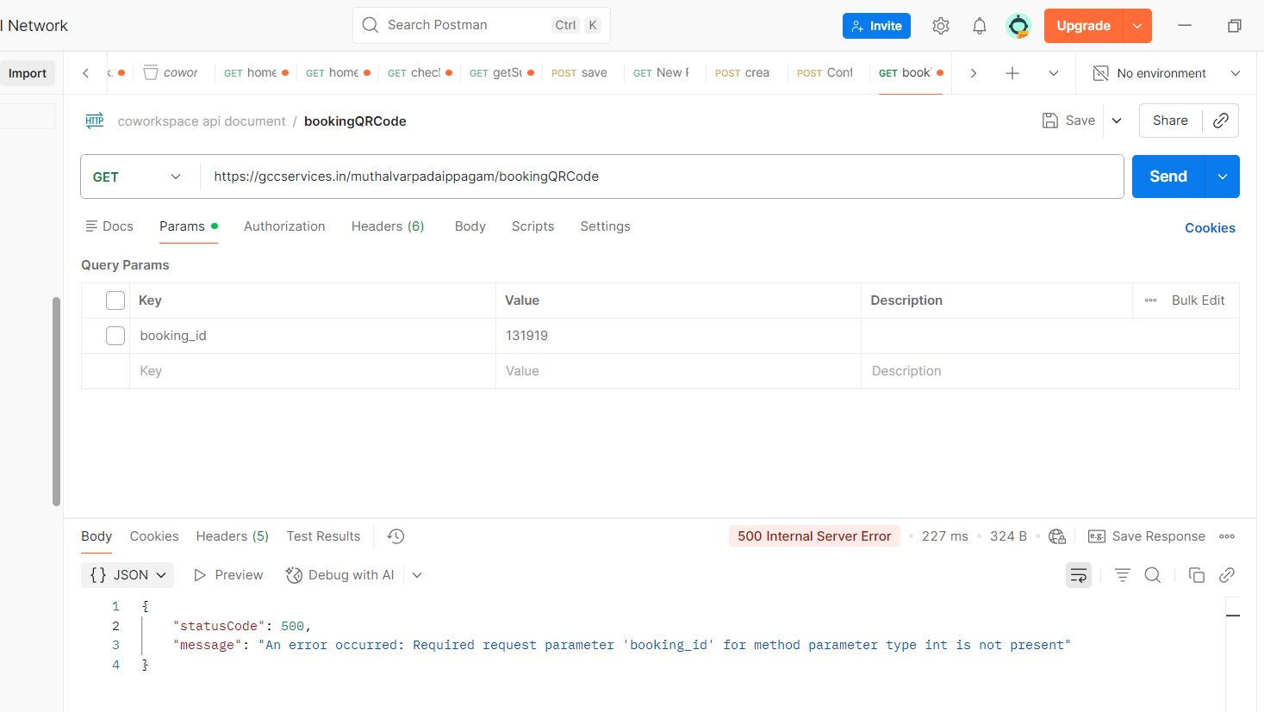

BOOKING HISTORY PAGE

API: /muthalvarpadaippagam/book/api/bookinghistory
Method: GET
Table: booking, slots, buildings, category
Parameters:
mobile → User mobile number
Purpose:
This API fetches the booking history of the user based on the registered mobile number.
Action:
The API receives the user's mobile number and retrieves the corresponding booking records along with the building, slot and category details.
Response Data:
The API returns the following booking details:
booking_id → Booking ID
buildingname → Building / Coworking Space Name
type_name → Booking category display name
duration → Selected time slot
from_date → Booking start date
to_date → Booking end date
checkin → Check-in time
checkout → Check-out time
no_of_person → Number of seats/persons
amount → Booking amount
status → Booking status
Usage:
The frontend calls this API when the user opens the Booking History page.
The returned booking details are displayed.
Postman:data getting from session
------------------
/muthalvarpadaippagam/bookingQRCode?booking_id=${bookingId}`;
API: /muthalvarpadaippagam/bookingQRCode?booking_id=${bookingId}`;
Reference:
This API is already used in the Worksdesk page. Please refer to the *Worksdesk Page – bookingQRCode API for the API details.

API: /muthalvarpadaippagam/book/api/sendOTP
Method: GET
Purpose:
This API sends an OTP to the provided mobile number for mobile number verification.
Request Parameter:
mobileNo → Mobile number to which the OTP should be sent
Example Request:
https://gccservices.in/muthalvarpadaippagam/book/api/sendOTP
?mobileNo=8974561230
Response Data:
The API returns the OTP submission status, description, and message tracking ID.
{
"status": 100,
"description": "Message submitted with tracking id ( UID )",
"messageid": "dcbhhdsbcdusbc"
}
status → Indicates the status of the OTP message submission
description → Description of the message submission status
messageid → Unique message/tracking ID generated for the submitted OTP
Usage:
The frontend calls this API when the user clicks the Send OTP button. The mobile number entered by the user is passed as the mobileNo parameter. If the OTP is successfully submitted, the OTP verification screen is displayed to the user.
Screenshot:

Success:
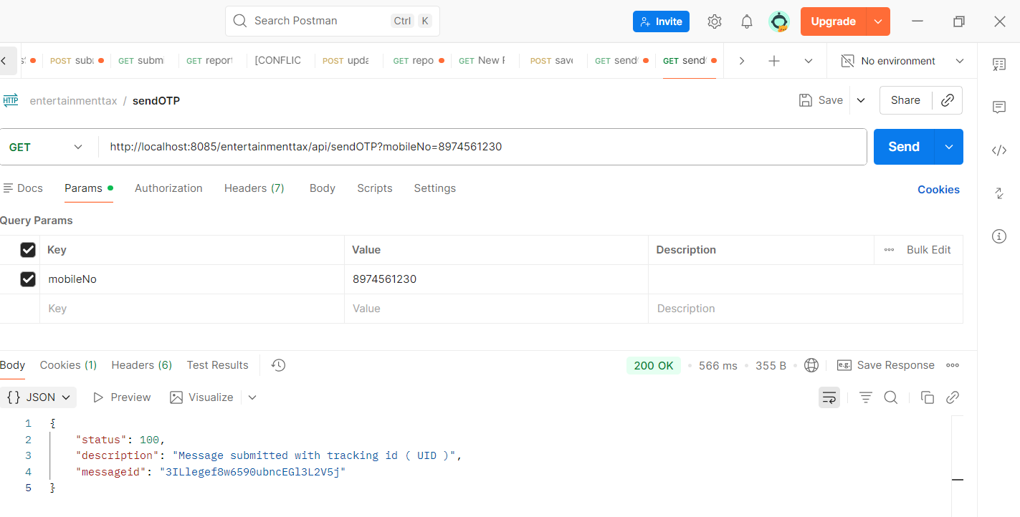
Failure

API: /muthalvarpadaippagam/book/api/verifyOTP
Method: GET
Purpose:
This API verifies the OTP entered by the user for mobile number verification during Booking History details.
Request Parameter:
otp → OTP entered by the user
Example Request
https://gccservices.in/muthalvarpadaippagam/book/api/verifyOTP
?otp=75901
Response Data:
The API returns a success response when the entered OTP is valid.
Success
Usage:
The frontend calls this API after the user enters the OTP received on their registered mobile number. If the response is Success, the mobile number is considered verified and then it is redirect to this
API: /muthalvarpadaippagam/book/api/bookinghistory

Screenshot:
Success:
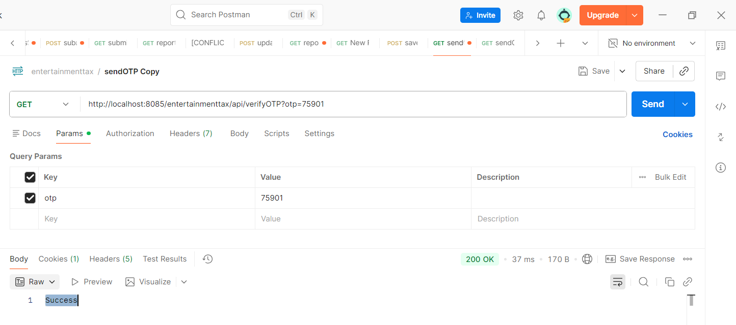
Failure:
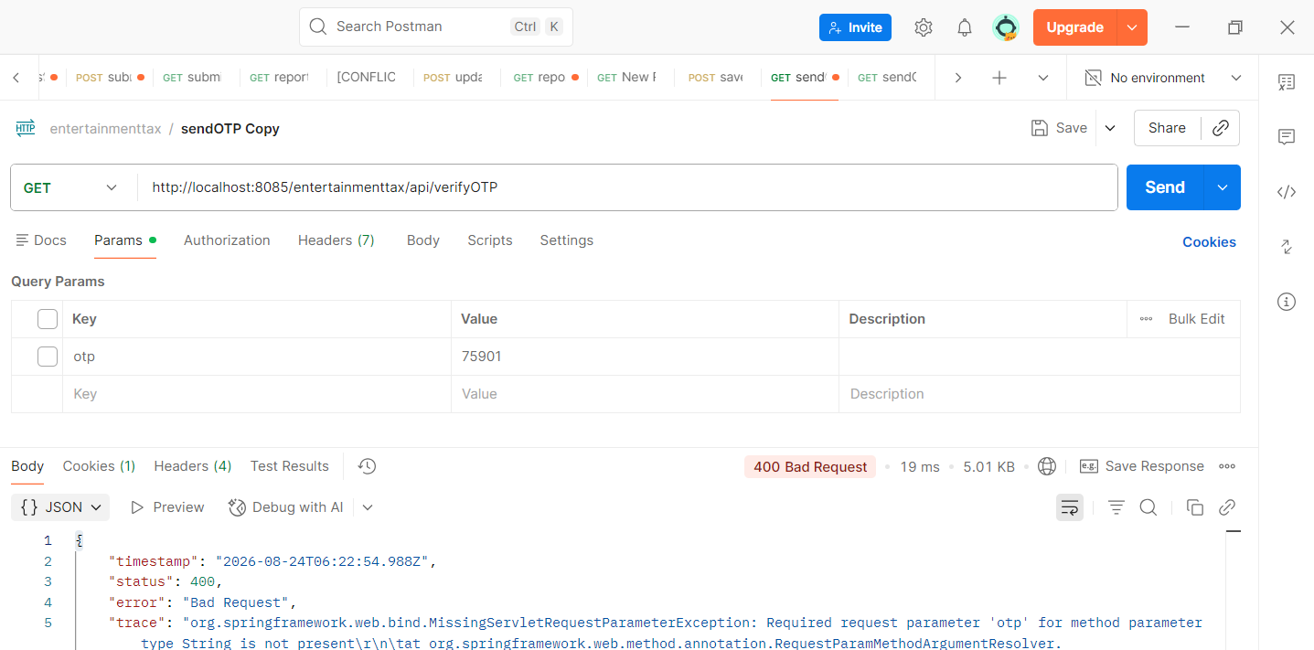

REGISTER COMPLAINT PAGE
API: /muthalvarpadaippagam/complaint/api/addnewcomplaint
Method: POST
Table: complaint_details, complaint_details_history
Parameters:
userName → Registered user name
remarks → Complaint remarks/details
mobileNumber → Registered mobile number
uploadPhotoFile → Complaint image uploaded by the user
Purpose:
This API is used to register a new complaint submitted by the user.
Action:
The API receives the user's complaint details and uploaded image, generates a unique complaint number, and saves the complaint.
The complaint details are saved in both:
- complaint_details → Stores the current complaint details.
- complaint_details_history → Stores the complaint history for tracking.
Response:
The API returns the number of database records successfully inserted.
Screenshot:
Success:
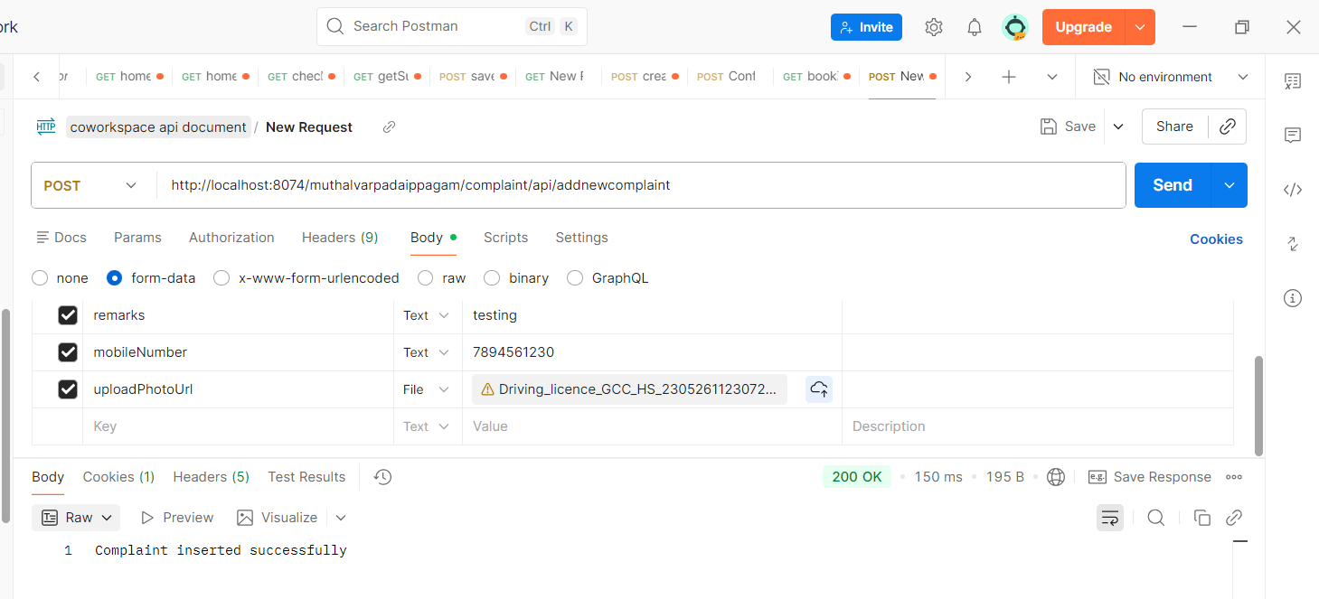
Failure:
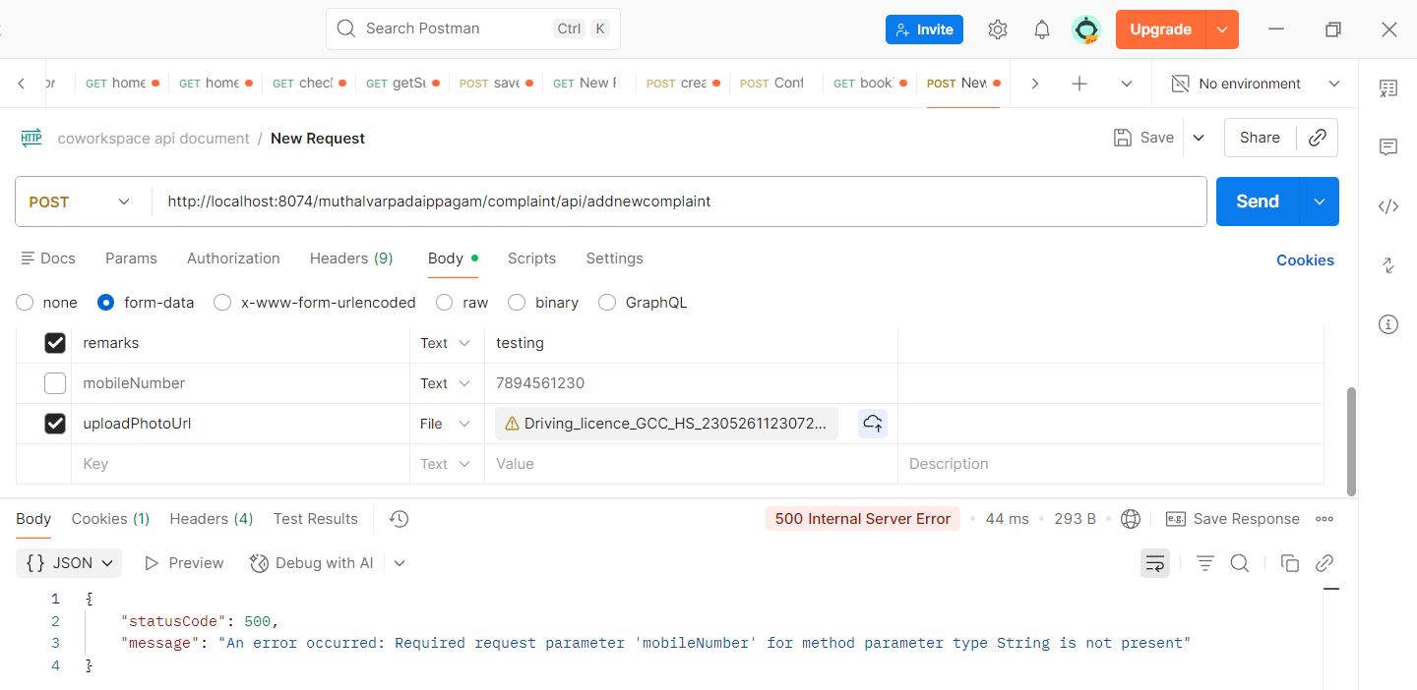
---------------------
API: /muthalvarpadaippagam/book/api/getComplaintsByMobile
Method: GET
Table: booking, complaint_details
Parameters:
mobileNo → User mobile number
Purpose:
This API fetches the user's registered details and complaint details based on the mobile number.
Action:
The API receives the user's mobile number and performs the following:
- Fetches the user's name and mobile number from the booking table.
- Fetches all complaints registered with the given mobile number from the complaint_details table.
- Retrieves the latest complaints first.
- Returns the user details along with the complaint list.
Response Data:
user_name → Registered user name
mobile → Registered mobile number
complaints → List of complaints
Each complaint contains:
complaint_no → Complaint number
remarks → User complaint remarks
upload_photo_url → User uploaded complaint image
caretaker_remarks → Caretaker remarks
caretaker_photo_url → Caretaker uploaded image
status → Current complaint status
Usage:
The frontend calls this API after a complaint is successfully verified OTP
It is also used to display the complaints associated with the verified user's mobile number.
The complaint list displays:
- Complaint Number
- User Remarks
- User Uploaded Image
- Caretaker Remarks
- Caretaker Image
- Status
The returned image paths are converted into complete image URLs before being displayed on the page.

Screenshot:
Success:
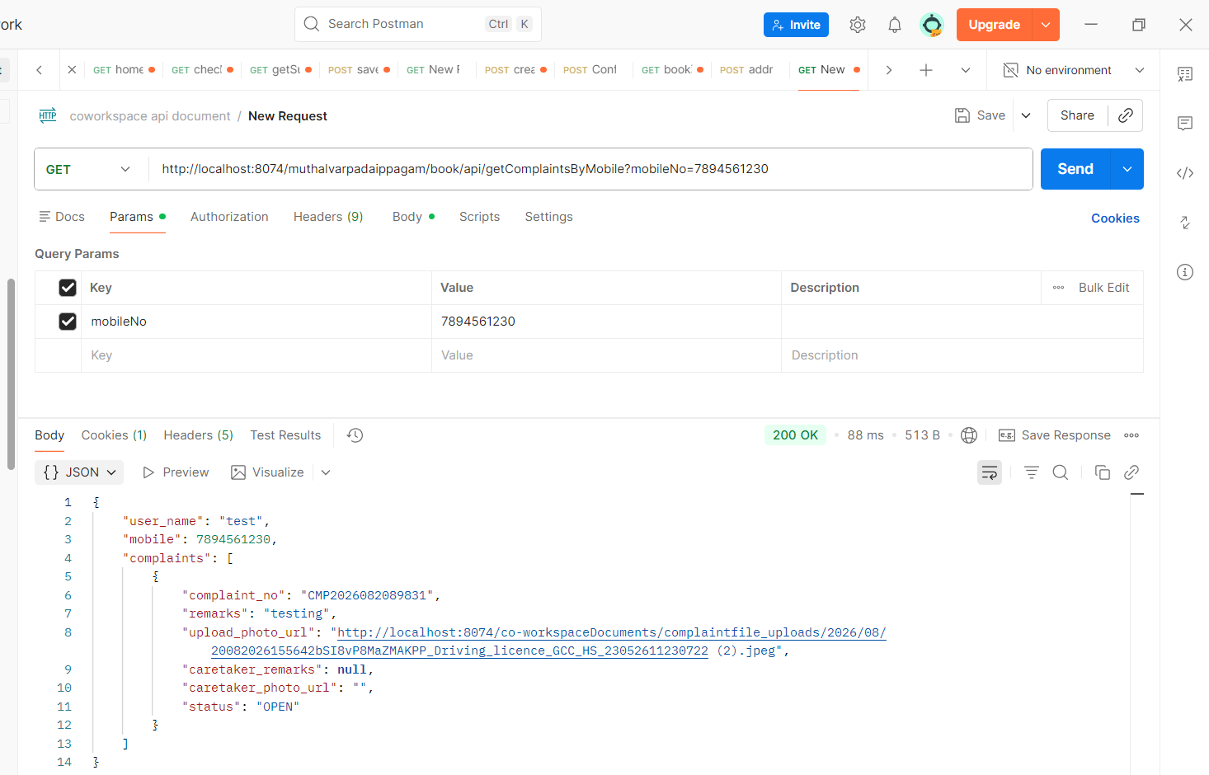

Failure:
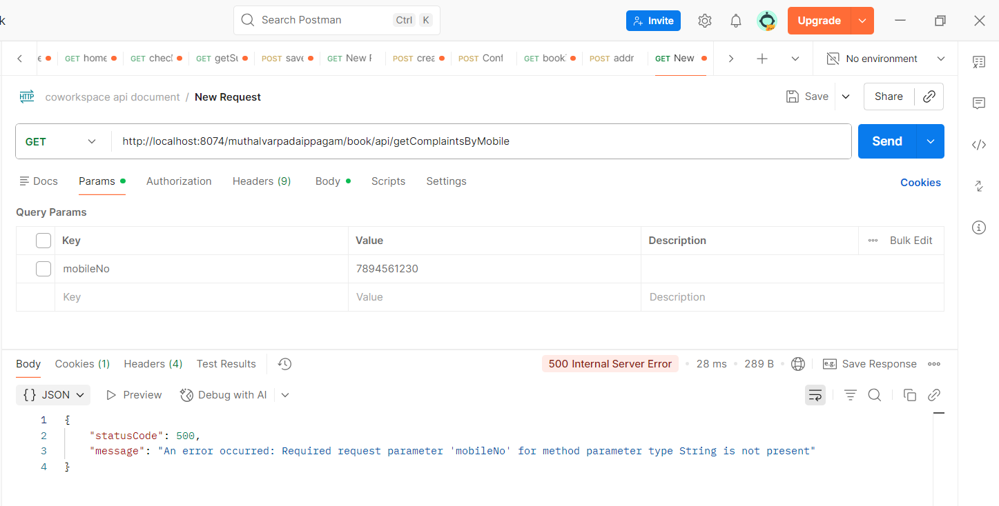

API: /muthalvarpadaippagam/complaint/api/complaintHistory?complaintNo=${complaintNo}
Method: GET
Table: complaint_details_history
Parameters:
complaintNo → Complaint Number
Purpose:
This API fetches the complete history of a particular complaint based on the complaint number.
Action:
The API receives the complaint number and retrieves all the history records associated with that complaint.
It also prepares the user and caretaker uploaded photo URLs and formats the complaint date and caretaker update date before returning the response.
Response Data:
complaint_no → Complaint number
cdate → Complaint created date
caretaker_updated_date → Caretaker updated date
user_name → User name
remarks → User complaint remarks
upload_photo_url → User uploaded complaint image
caretaker_remarks → Caretaker remarks
caretaker_photo_url → Caretaker uploaded image
Usage:
The frontend calls this API when the user clicks on a complaint to view its history.
The returned history is displayed in the Complaint History popup/table.
Response:
The API returns a list of complaint history records for the given complaint number.
If no history is available, the history table will contain no records.
Screenshot:

Success:
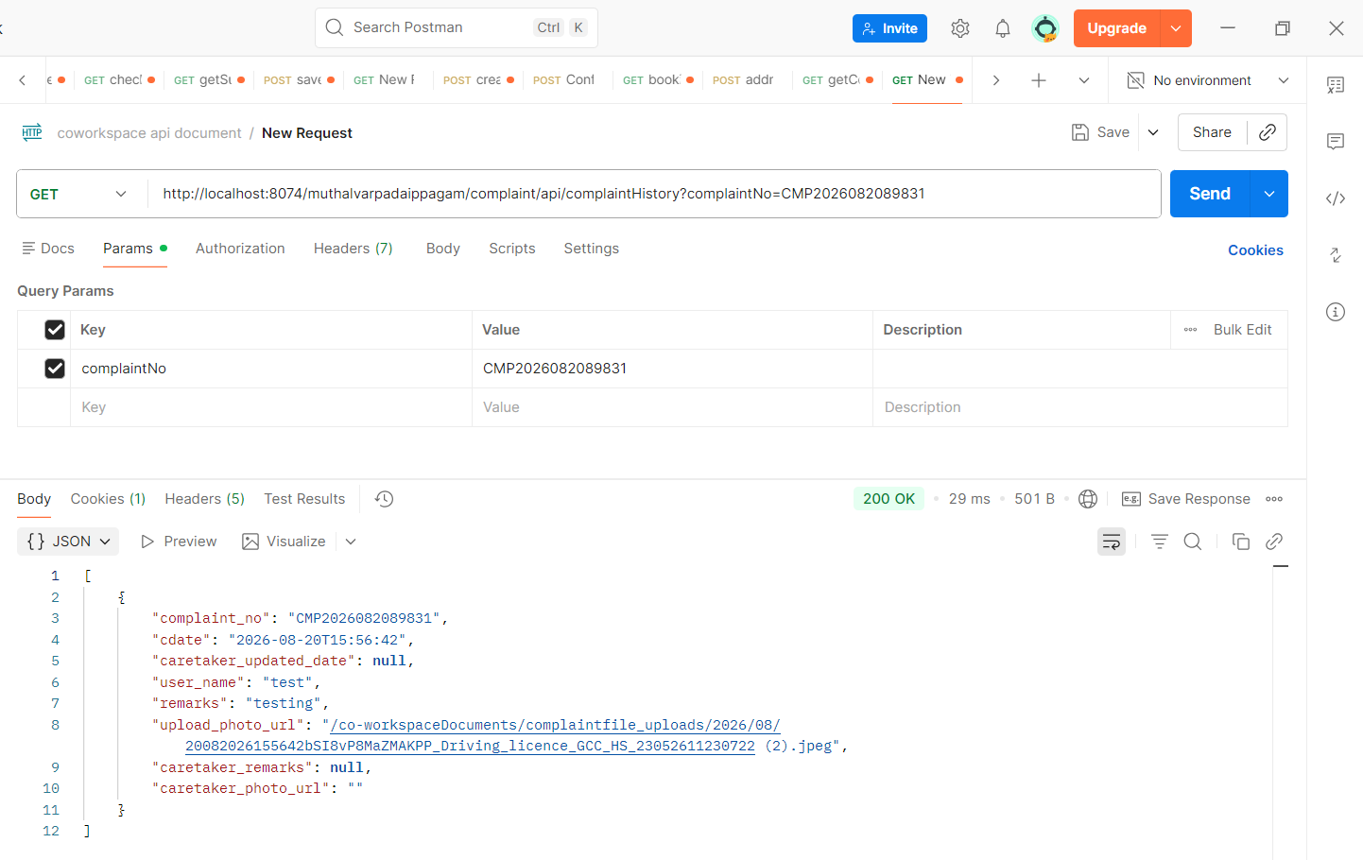

Failure:
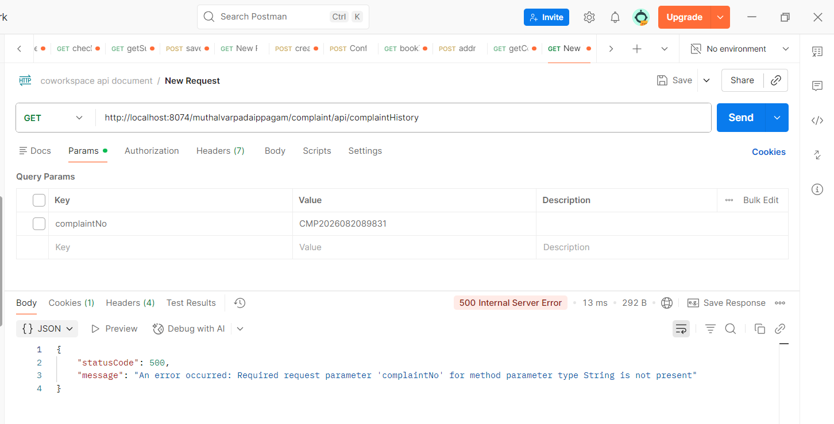

CARETAKER SIDE
Dashboard page:

API: /muthalvarpadaippagam/book/api/amountCollected
Method: GET
Table: booking
Parameters:
fromDate → Start date for the report
toDate → End date for the report
bid → Building ID
Purpose:
This API fetches the amount collected for the selected building and date range.
Action:
The API receives the fromDate, toDate and bid, and retrieves the successful booking payment amounts for the selected period and building.
The amount is categorized into:
- Overall Amount Collected
- Desk Space Amount Collected
- Conference Hall / Meeting Room Amount Collected
- Learning Centre Amount Collected
Only bookings with a successful booking status are considered.
Response Data:
overall_amount_collected → Total amount collected
desk_space_amount_collected → Amount collected from Desk Space bookings
meeting_room_amount_collected → Amount collected from Meeting Room bookings
learning_zone_amount_collected → Amount collected from Learning Centre bookings
Usage:
The frontend calls this API when the Dashboard page is loaded and whenever the user changes the From Date or To Date.
The returned values are displayed in the Dashboard amount cards:
- Overall Amount Collected
- Desk Space - Amount Collected
- Conference Hall - Amount Collected
- Learning Centre - Amount Collected
Screenshot:
Success:
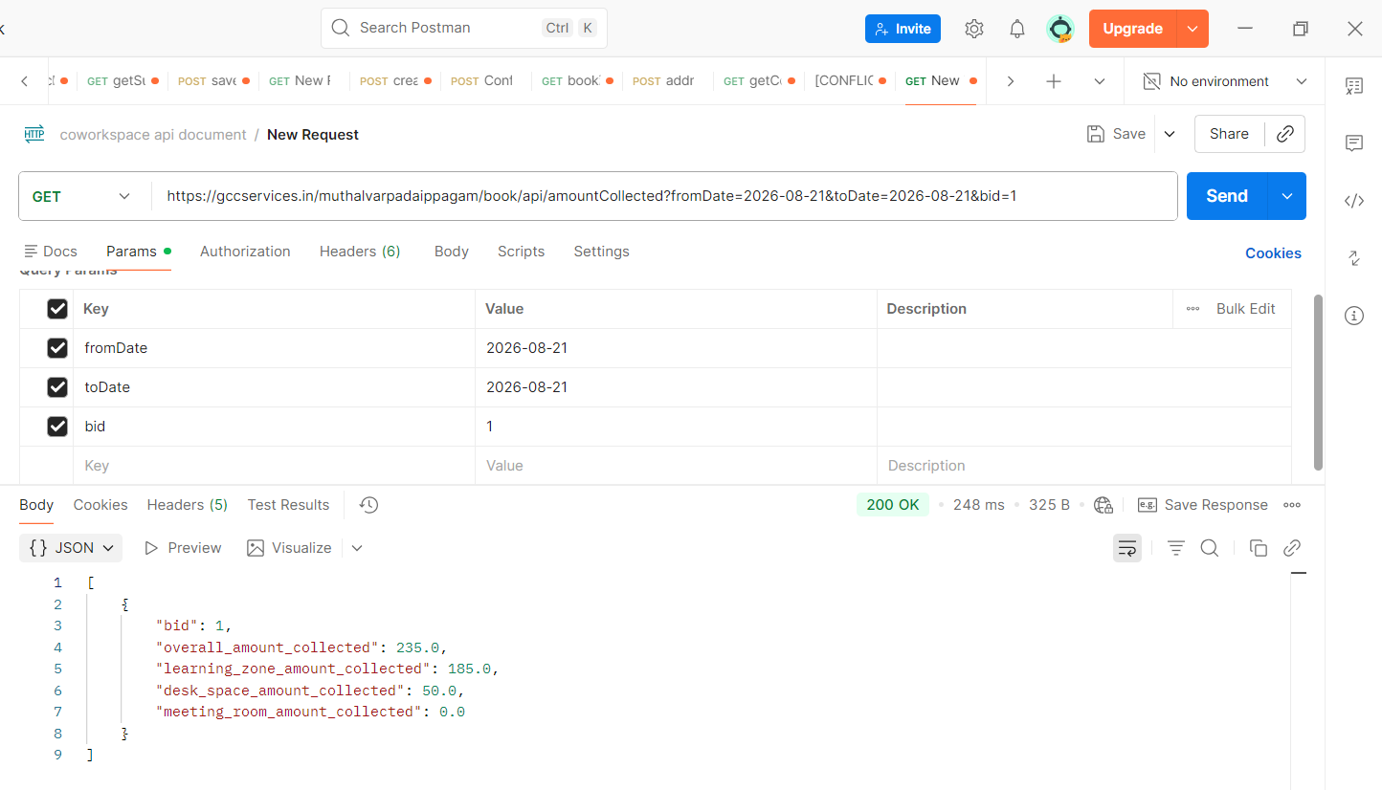
Failure:
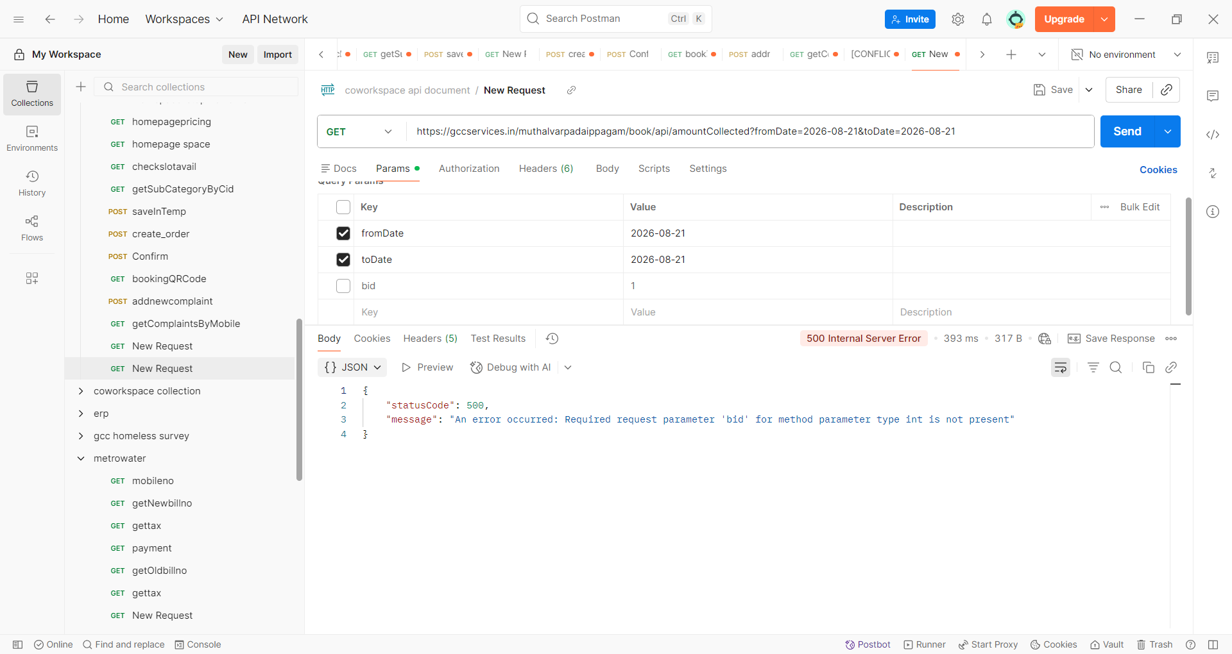
-------------------------------------------------
API: /muthalvarpadaippagam/book/api/bookingCountByCategory
Method: GET
Table: booking
Parameters:
fromDate → Start date for the report
toDate → End date for the report
bid → Building ID
Purpose:
This API fetches the number of successful bookings for each booking type and slot category for the selected building and date range.
Action:
The API receives the fromDate, toDate and bid and retrieves the successful booking counts for the selected period and building.
The booking counts are categorized into:
- Learning Centre slots
- Desk Space – Half Day
- Desk Space – Full Day
- Desk Space – Monthly
- Meeting Room No. 1
- Meeting Room No. 2
- Meeting Room No. 3
Response Data:
slotId_1_count → Learning Centre Slot 1 booking count
slotId_2_count → Learning Centre Slot 2 booking count
slotId_3_count → Learning Centre Slot 3 booking count
slotId_4_count → Learning Centre Slot 4 booking count
slotId_5_count → Learning Centre Slot 5 booking count
half_day_count → Desk Space Half Day booking count
full_day_count → Desk Space Full Day booking count
monthly_count → Desk Space Monthly booking count
RoomNo1_Count → Meeting Room 1 booking count
RoomNo2_Count → Meeting Room 2 booking count
RoomNo3_Count → Meeting Room 3 booking count
Usage:
The frontend calls this API on the Dashboard page to display the booking counts in the category-wise charts.
The returned values are used to display:
- Desk Space – Half Day, Full Day and Monthly bookings
- Conference Hall / Meeting Room – Room 1, Room 2 and Room 3 bookings
- Learning Centre – Slot 1 to Slot 5 bookings
The API is called when the Dashboard page loads and whenever the From Date or To Date is changed.
Screenshot:
Success:
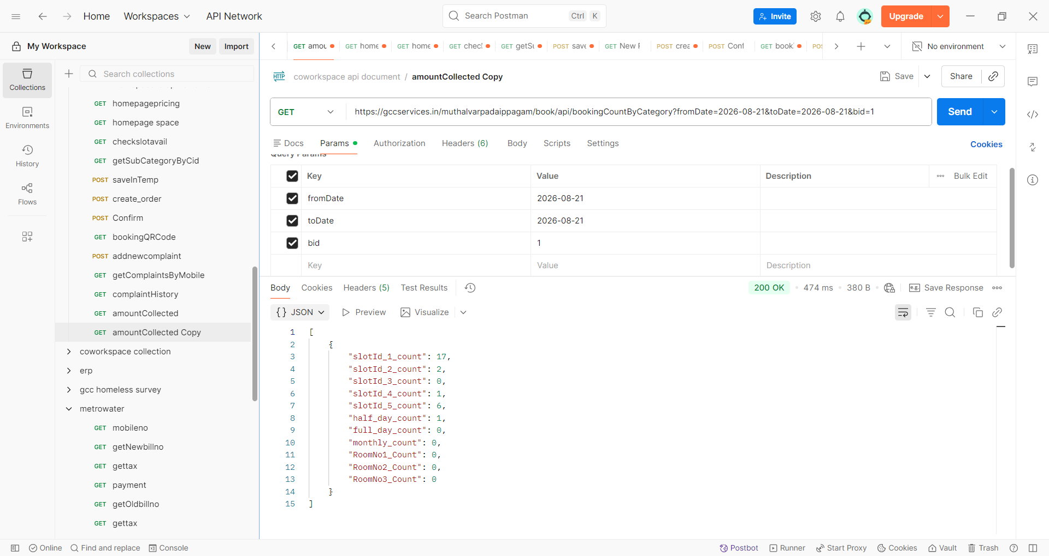
Failure:
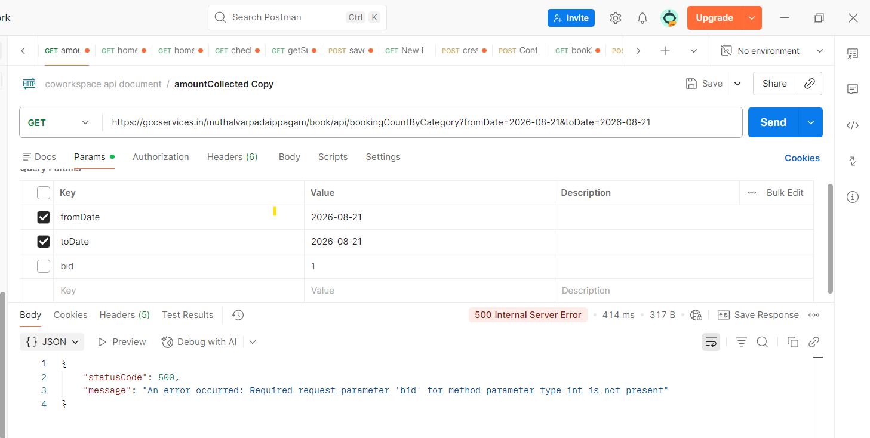

API: /muthalvarpadaippagam/book/api/totalBookingCounts
Method: GET
Table: booking
Parameters:
fromDate → Start date for the report
toDate → End date for the report
bid → Building ID
Purpose:
This API fetches the overall number of successful bookings for the selected building and date range.
Action:
The API receives the fromDate, toDate and bid and retrieves the total booking count along with category-wise booking counts for the selected period and building.
The booking counts are categorized into:
- Total Bookings
- Learning Centre
- Desk Space
- Meeting Room
Response Data:
Total_booking_count → Total number of successful bookings
Learning_zone_count → Total number of Learning Centre bookings
Desk_space_count → Total number of Desk Space bookings
Meeting_room_count → Total number of Meeting Room bookings
Usage:
The frontend calls this API on the Dashboard page to display the overall booking counts.
The returned values are used to show the total number of bookings and the category-wise booking counts for the selected date range and building.
Scrrenshoot:
Success:
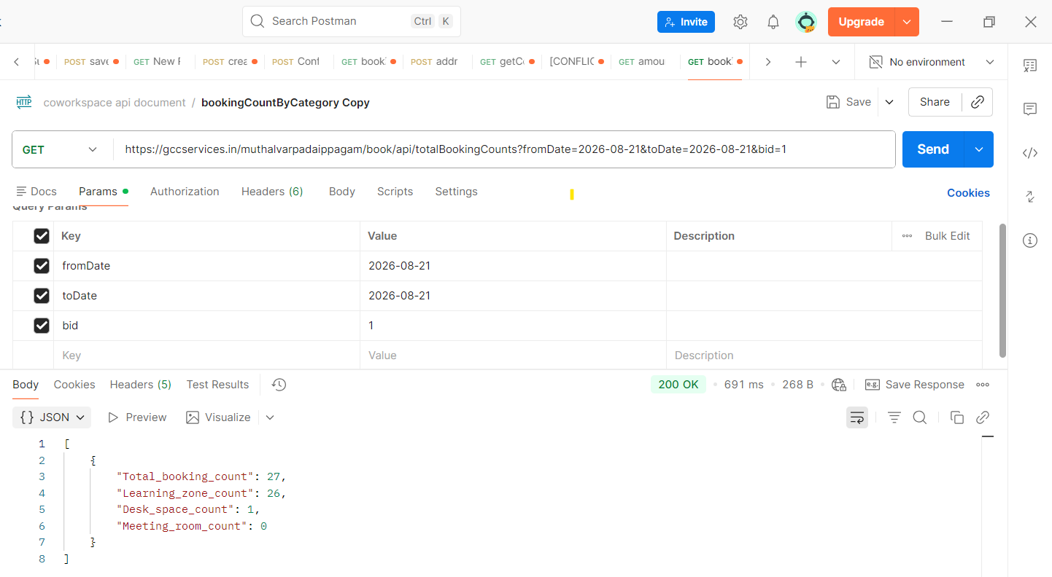
Failure:
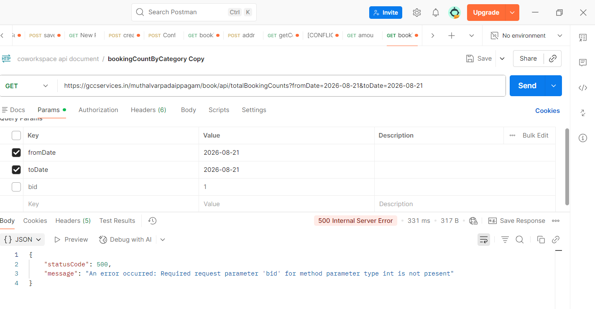

API: /muthalvarpadaippagam/book/api/getbookingdetailDashBoard
Method: GET
Table: booking, slots, buildings, category
Parameters:
fromDate → Start date for the report
toDate → End date for the report
bid → Building ID
status → Booking status filter
Purpose:
This API fetches the booking details for the selected building and date range, with an optional booking status filter.
Action:
The API receives the fromDate, toDate, bid and status, and retrieves the matching booking records.
The API also fetches the related:
- Building name
- Booking category
- Slot / duration
- Check-in time
- Check-out time
The booking status is determined as:
Completed → Booking date has passed
Upcoming → Booking is scheduled for a future date
Ongoing → Booking is currently active
Response Data:
booking_id → Booking ID
user_name → User name
mobile → User mobile number
building_name → Building / Coworking Space Name
type_name → Booking category name
duration → Selected time slot
booked_date → Booking created date
from_date → Booking start date
to_date → Booking end date
checkin → Check-in time
checkout → Check-out time
no_of_seats → Number of seats/persons
amount → Booking amount
status → Booking status
duration_hours → Booking duration in hours
Usage:
The frontend calls this API on the Dashboard page to display the detailed booking list.

Screenshot:
Success:
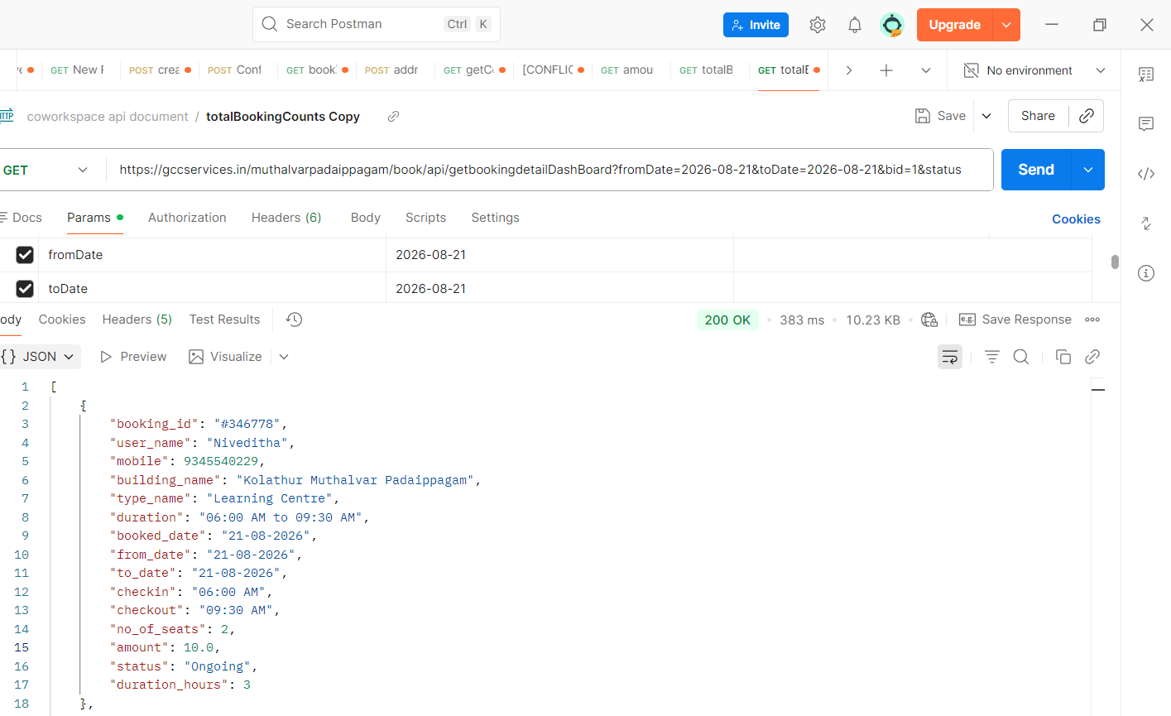
Failure
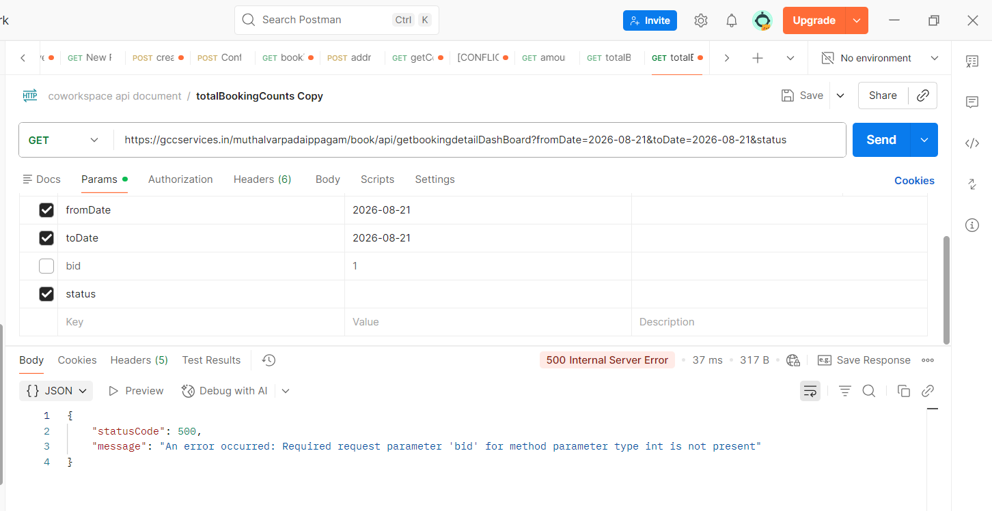
Reports page:
API: /muthalvarpadaippagam/book/api/reports/getslotdateReports
Method: GET
Table: booking, buildings, slots, category, subcategory, calendar
Parameters:
fromDate → Start date for the report
toDate → End date for the report
type → Category filter
status → Booking status filter
filterBy → Filter based on Slot Date or Booking Date
type1 → Sub-Category filter
bid → Building ID
Purpose:
This API fetches booking report details based on the slot date, date filter, category, sub-category, status and building.
Action:
The API retrieves the matching booking records and their related building, slot, category, sub-category and calendar details.
The report can be filtered based on:
- Slot Date → Filters bookings based on the actual slot/usage date.
- Booking Date → Filters bookings based on the date when the booking was created.
- Category → Learning Centre, Desk Space or Meeting Rooms.
- Sub-Category → Half Day, Full Day, Month or Meeting Room.
- Status → Ongoing, Completed or Upcoming.
- Building → Selected building.
Response Data:
booking_id → Booking ID
building_name → Building / Coworking Space Name
bid → Building ID
user_name → User name
mobile → User mobile number
display_name → Category / Subcategory display name
bdate → Slot date
from_date → Booking start date
to_date → Booking end date
checkin → Check-in time
checkout → Check-out time
no_of_person → Number of seats/persons
amount → Booking amount
payment_status → Payment status
bdate → Slot booking date
type → Booking category
type_name → Category display name
subcategory_name → Sub-category name
status → Booking status
Usage:
The frontend calls this API on the Reports page to display the booking report based on the selected filters. The report page provides From Date, To Date, Slot Date/Booking Date, Category, Sub-Category and Status filters.
When Slot Date is selected, the API filters the report based on the slot date and displays the result in the Slot Date report table.
When Booking Date is selected, the corresponding booking-date report API is used and the Booking Date table is displayed.

Screenshot:
Success:
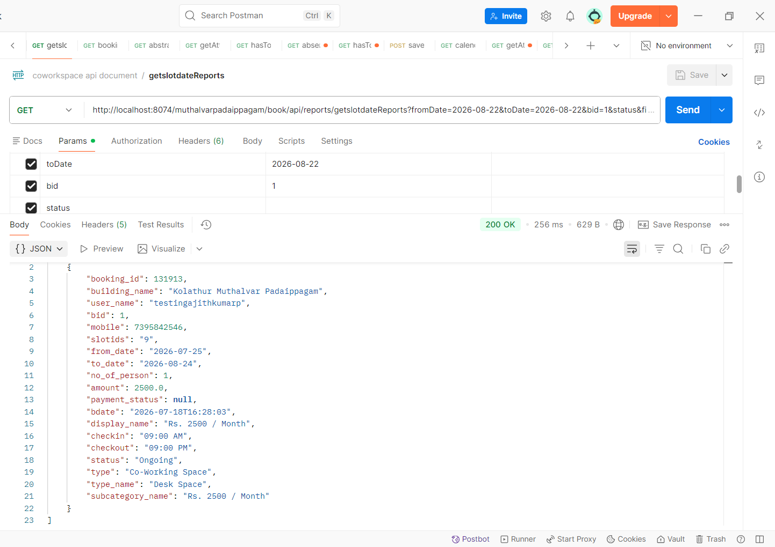
API: /muthalvarpadaippagam/book/api/reports/getbookingdateReports
Method: GET
Table: calendar, booking, buildings, slots, subcategory, category
Parameters:
fromDate → Start date for the report
toDate → End date for the report
type → Category filter
status → Booking status filter
filterBy → Report filter type
type1 → Sub-Category filter
bid → Building ID
Purpose:
This API fetches booking details based on the booking date for the selected date range, building, category, sub-category and status.
Action:
The API receives the selected filters and retrieves the corresponding booking records based on the booking date stored in the calendar table.
The API supports filtering by:
- Building
- Category
- Sub-Category
- Booking Status
- Booking Date Range
Response Data:
booking_id → Booking ID
bid → Building ID
building_name → Building / Coworking Space Name
user_name → User name
mobile → User mobile number
type_name → Category display name
display_name → Sub-category / Pricing option name
duration → Selected time slot
from_date → Booking start date
to_date → Booking end date
cdate → Booking created date
checkin → Check-in time
checkout → Check-out time
no_of_person → Number of seats/persons
amount → Booking amount
payment_status → Payment status
status → Booking status
Usage:
The frontend calls this API when Booking Date is selected in the Reports page.
The returned data is displayed in the Booking Date Report table.

Screenshot:
Success:
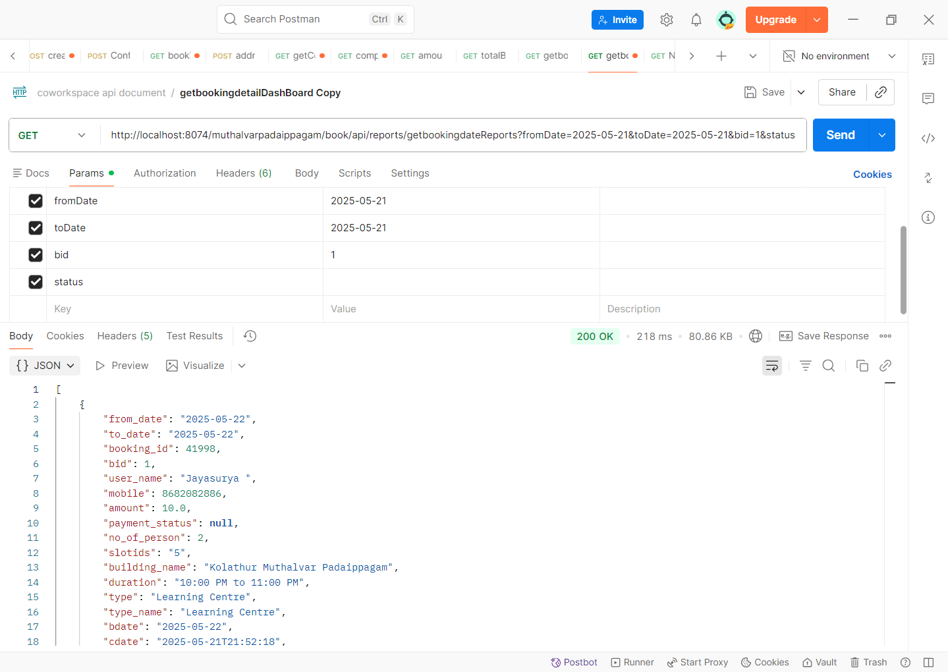

Abstract page
API: /muthalvarpadaippagam/book/api/reports/abstractReport
Method: GET
Table: booking, buildings, category, subcategory, slots
Parameters:
fromDate → Start date for the report
toDate → End date for the report
type → Category filter
type1 → Sub-Category filter
bid → Building ID
Purpose:
This API fetches an abstract summary of successful bookings for the cdate range, category, sub-category and building.
Action:
The API retrieves successful booking records and groups the booking information based on:
- Booking date
- Building
- Category
- Sub-Category
- Slot
It returns the total booking amount and total number of persons for each group.
Response Data:
created_date → Booking created date
building_id → Building ID
building_name → Building name
category → Category display name
type → Sub-Category / Pricing option name
slots → Selected time slot
amount → Total booking amount for the group
NO_of_person → Total number of persons for the group
Usage:
The frontend calls this API on the Abstract Report page.

Screenshot:
Success:
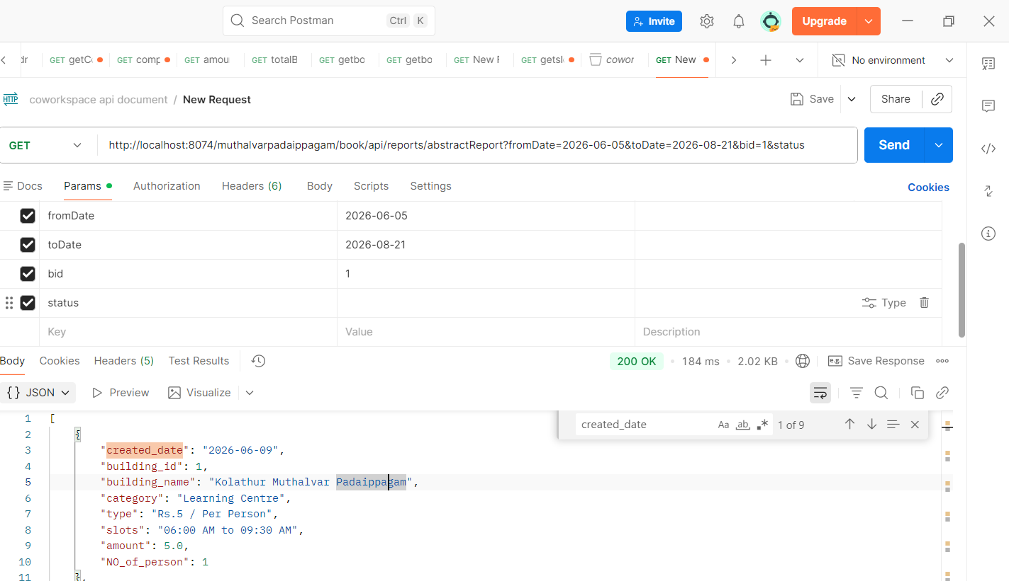
---------------------------------
Booking Details
API: /muthalvarpadaippagam/book/api/bookinghistorydetails
Method: GET
Table: booking, slots, buildings, category
Parameters:
mobileno → User mobile number
Purpose:
This API fetches the booking details associated with the user's mobile number.
Action:
The API receives the user's mobile number and retrieves the corresponding booking records along with the building, slot and category details.
Response Data:
booking_id → Booking ID
user_name → User name
mobile → User mobile number
buildingname → Building / Coworking Space Name
type_name → Booking category display name
duration → Selected time slot
from_date → Booking start date
to_date → Booking end date
cdate → Booking created date
checkin → Check-in time
checkout → Check-out time
no_of_person → Number of seats/persons
amount → Booking amount
payment_status → Payment status
status → Booking status
Usage:
The frontend calls this API when the user enters a valid 10-digit mobile number and clicks Get Details.

Screenshot:
Success:
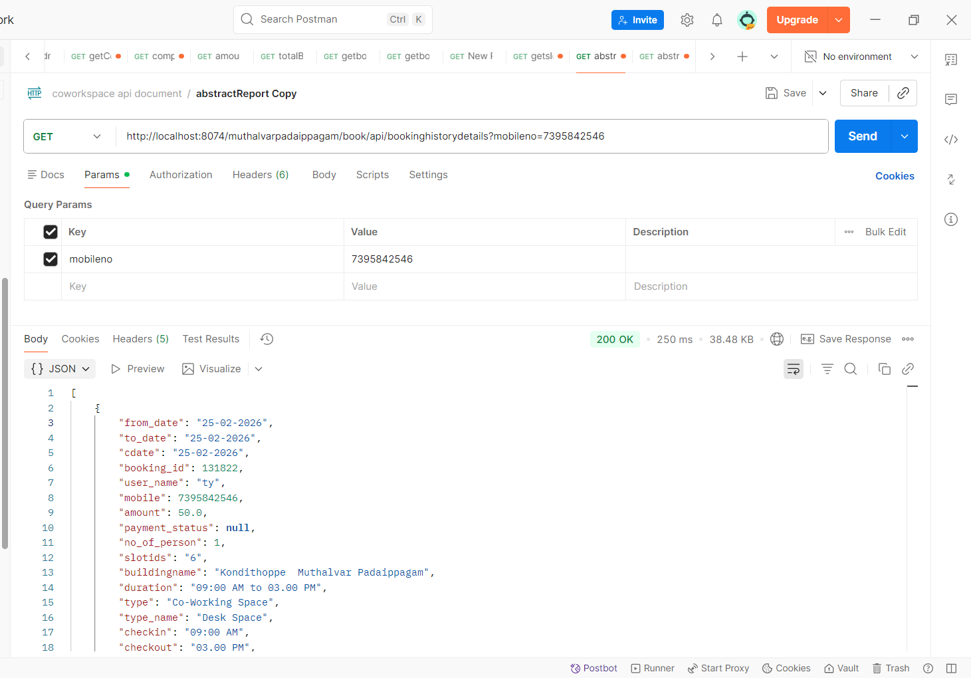
Failure:
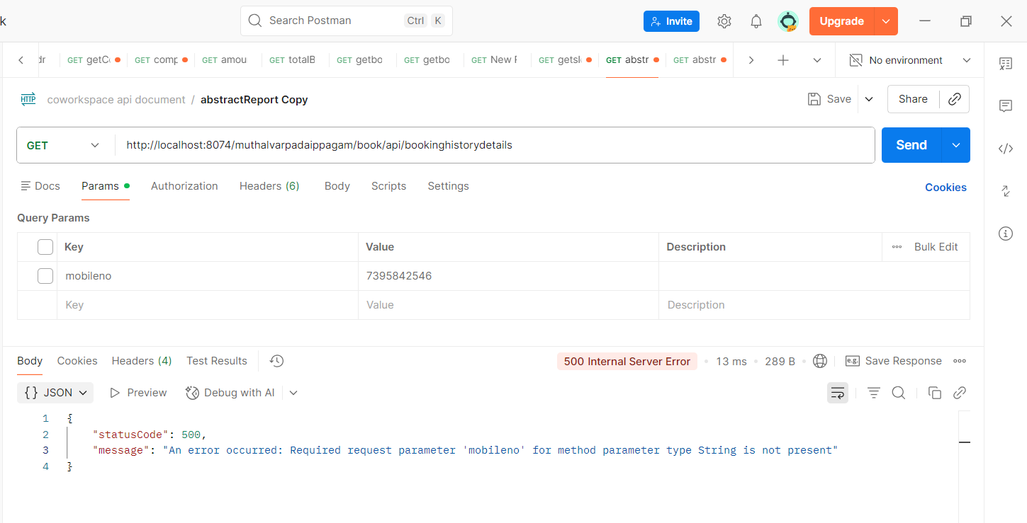

API: /muthalvarpadaippagam/bookingQRCode?booking_id=${bookingId}`;
Reference:
This API is already used in the Worksdesk page. Please refer to the *Worksdesk Page – bookingQRCode API for the API details.

Attendance:
Attendance Button Availability:
The attendance action button is enabled only during the configured attendance time window.
Attendance Time:
Start Time → 10:30 AM
End Time → 11:30 AM

API: Get Attendance Details
API URL:
/muthalvarpadaippagam/book/api/attendance/getAttendance
Method: GET
Purpose:
This API retrieves the attendance-related booking details for the Desk Space category. It loads the bookings into the Attendance DataTable and allows filtering based on the number of persons and building.
Request Parameters
Parameter | Description
noOfPerson | Filters bookings based on the number of persons
bid | Filters bookings based on the selected building
type | Optional category name filter
typeName | Optional category display name filter
fromDate | Optional attendance/slot start date
toDate | Optional attendance/slot end date
The page currently sends noOfPerson and bid when the Attendance form is submitted.
Backend Processing
The API retrieves:
- Booking ID
- User name
- Mobile number
- Booking dates
- Number of persons
- Booking amount
- Number of absent persons
- Slot name
- Check-in time
- Check-out time
- Category
- Sub-category
- Booking count
It joins the calendar, booking, slots, category, subcategory, buildings, and attendance tables.
The API specifically restricts the results to:
- Category: Desk Space
- Slot: 09:00 AM to 09:00 PM
It then groups the result by bookingid and orders the records by the latest booking/slot date.
Frontend Action
When the user submits the Attendance filter:
- Building ID and number of persons are collected.
- The getAttendance API is called.
- Displayed the API response.
Screenshot:
Success:
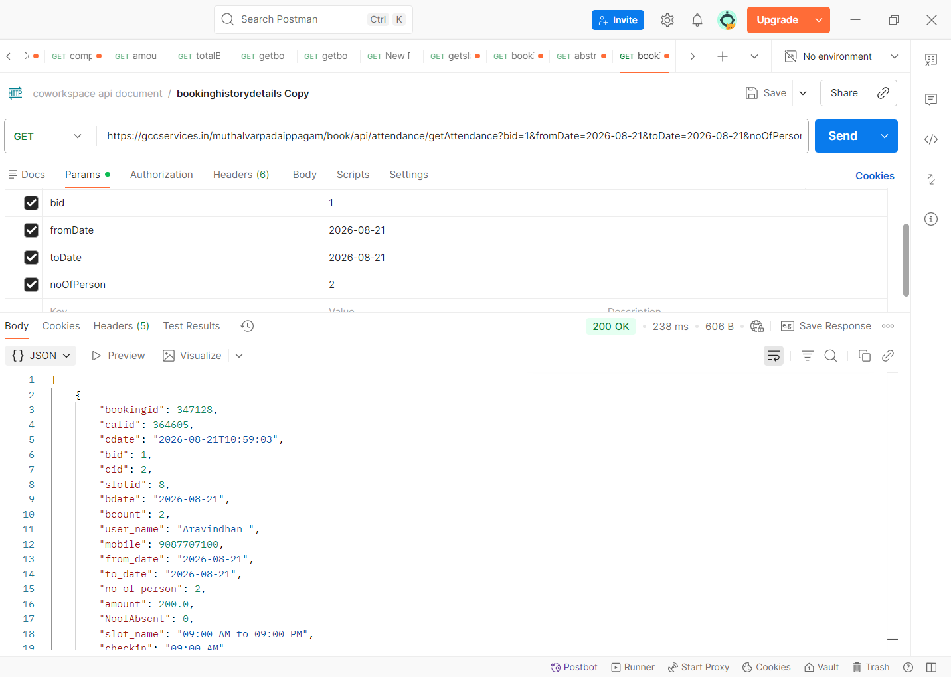

API: /muthalvarpadaippagam/book/api/attendance/hasTodayAttendance
Method: GET
Table: attendance
Parameters:
bookingId → Booking ID
Purpose:
This API checks whether attendance has already been marked for the selected booking on the current day.
Action:
The API receives the bookingId and checks the attendance table for an attendance record created on the current date.
Response:
true → Attendance has already been marked for the booking today.
false → Attendance has not been marked for the booking today.
Usage:
The frontend calls this API for each booking displayed in the Attendance table.
Based on the response:
- If attendance is already marked, the existing No. of Absent value is selected in the dropdown.
- If attendance is not yet marked, the No. of Absent value defaults to 0.
- The dropdown options are generated from 0 up to the total number of persons for that booking.

Screenshot:
Success:
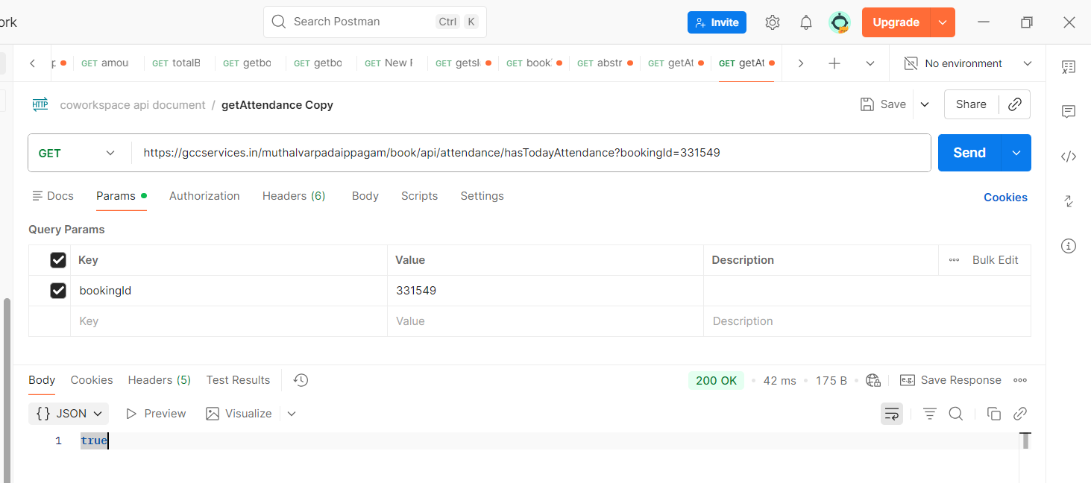

Failure:
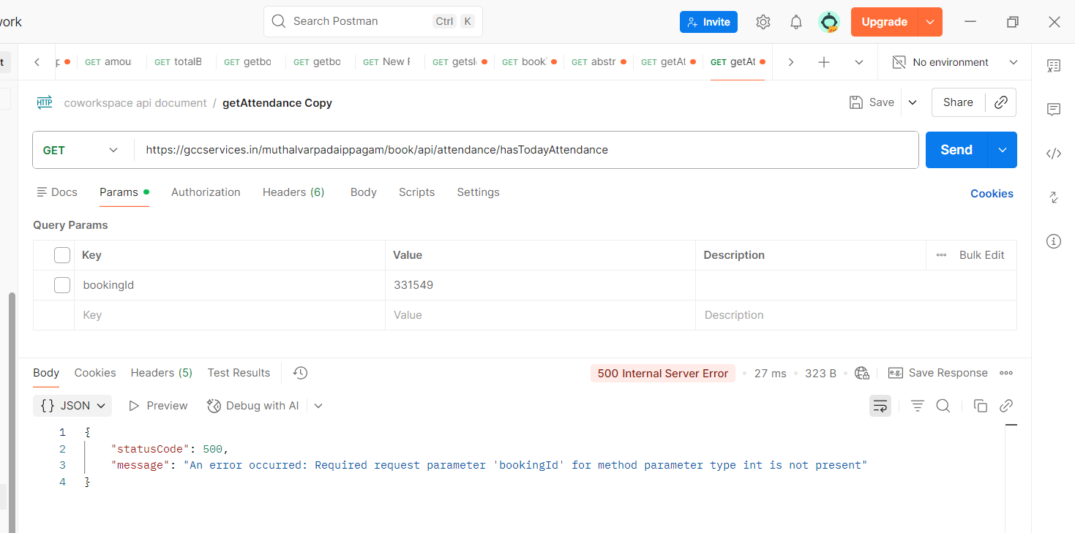

API: /muthalvarpadaippagam/book/api/attendance/absentCountToday
Method: GET
Table: calendar
Parameters:
bid → Building ID
Purpose:
This API fetches the total number of absent persons for the current day for the selected building.
Action:
The API receives the bid and calculates the total absent count from the calendar table for the current date.
The absent_count values for all applicable calendar records are summed.
Response:
The API returns a total number of absent persons for today.
Screenshot:
Success: 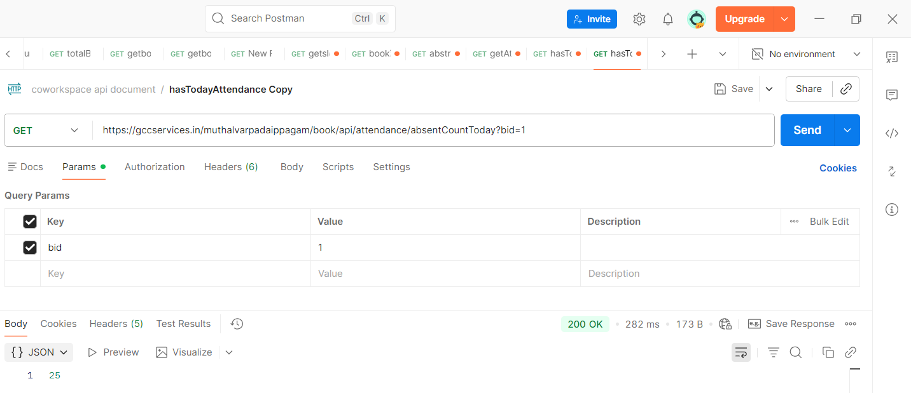

Failure:

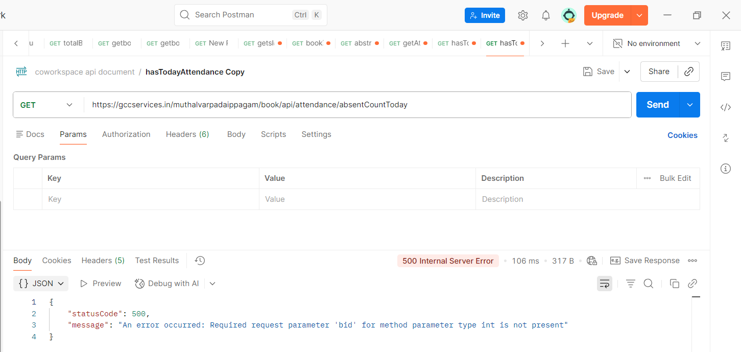

-----------------------------------------
API: /muthalvarpadaippagam/book/api/attendance/hasTodayAttendance
Method: GET
Table: absent_count
Purpose:
This API checks whether attendance has already been marked for the current day for the selected building.
Request Parameters:
buildingid → Building ID
it will be static 1
Response Data:
The API returns a boolean value:
true → Attendance has already been marked for today.
false → Attendance has not been marked for today.
Usage:
The frontend calls this API when loading the Attendance page to check whether today's attendance is already available for the selected building.
If attendance is already marked:
- The Close Attendance button is hidden.
- The attendance dropdown fields are disabled.
If attendance is not marked:
- The Close Attendance button is displayed.
The API checks the absent_count table using the current date, building ID, active status, and delete status.
Note: Attendance functionality is currently maintained for Building ID 1 only. Therefore, the frontend currently passes buildingid = 1
Screenshot:
Success:
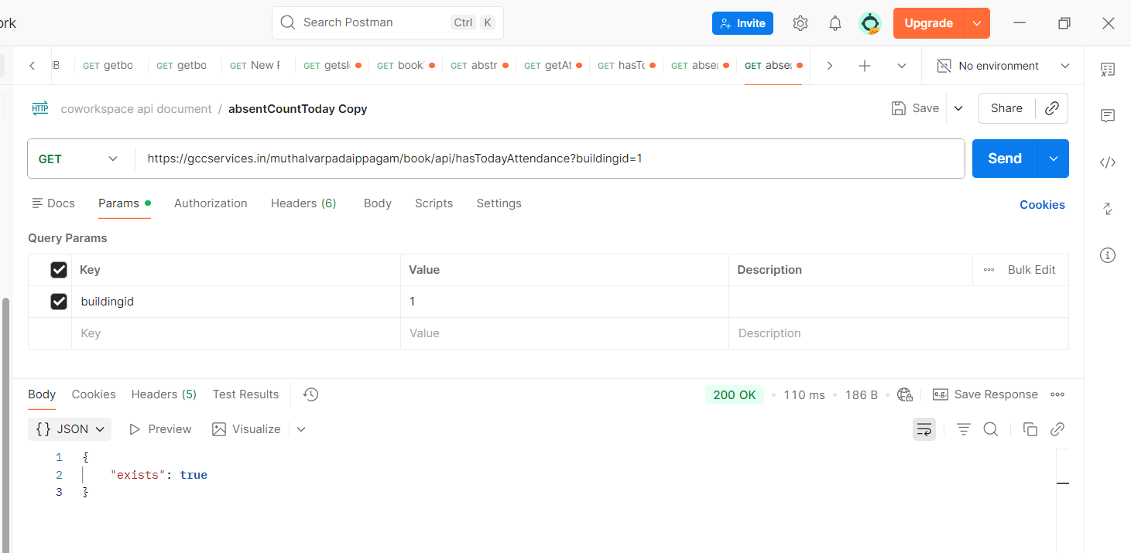

Failure:
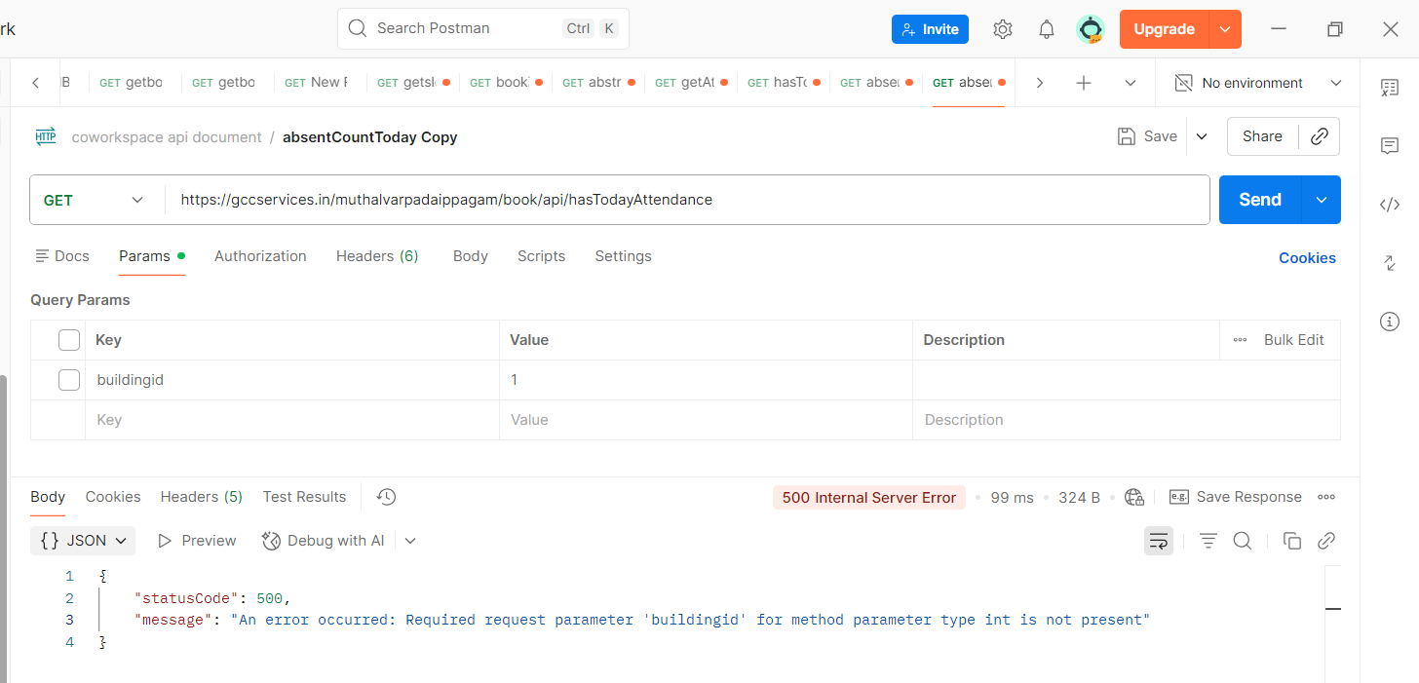

API: /muthalvarpadaippagam/book/api/attendance/saveAbsent
Method: POST
Table: attendance, calendar, absent_count
Parameters:
bid → Building ID
absentDate → Attendance date
absentList → List containing booking ID and number of absent persons
Purpose:
This API closes the attendance for the current day by saving the absent count for each booking and updating the total absent count for the selected building.
Action:
The API receives the selected absent count for each booking and performs the following actions:
- Saves the attendance details in the attendance table.
- Updates the absent_count in the calendar table for the corresponding booking.
- Calculates the total absent count for the selected building for the current day.
- Saves the total absent count in the absent_count table.
Request Data:
absentList:
bookingId → Booking ID
noOfAbsent → Number of absent persons
Database Updates:
attendance → Stores the absent count for each booking.
calendar → Updates the absent_count for the corresponding booking and current date.
absent_count → Stores the total absent count for the selected building and attendance date.
Response:
Successful:
{
"success": true,
"message": "Attendance saved and calendar updated."
}
If attendance processing fails:
{
"success": false,
"message": "Failed to process attendance."
}
Usage:
The frontend calls this API when the user clicks Close Attendance and confirms the attendance closing.
Before calling the API, the frontend collects the No. of Absent value for each booking and calculates the total absent count.
After successful submission, the page displays:
Attendance Closed
and reloads the Attendance page.

Screenshot: 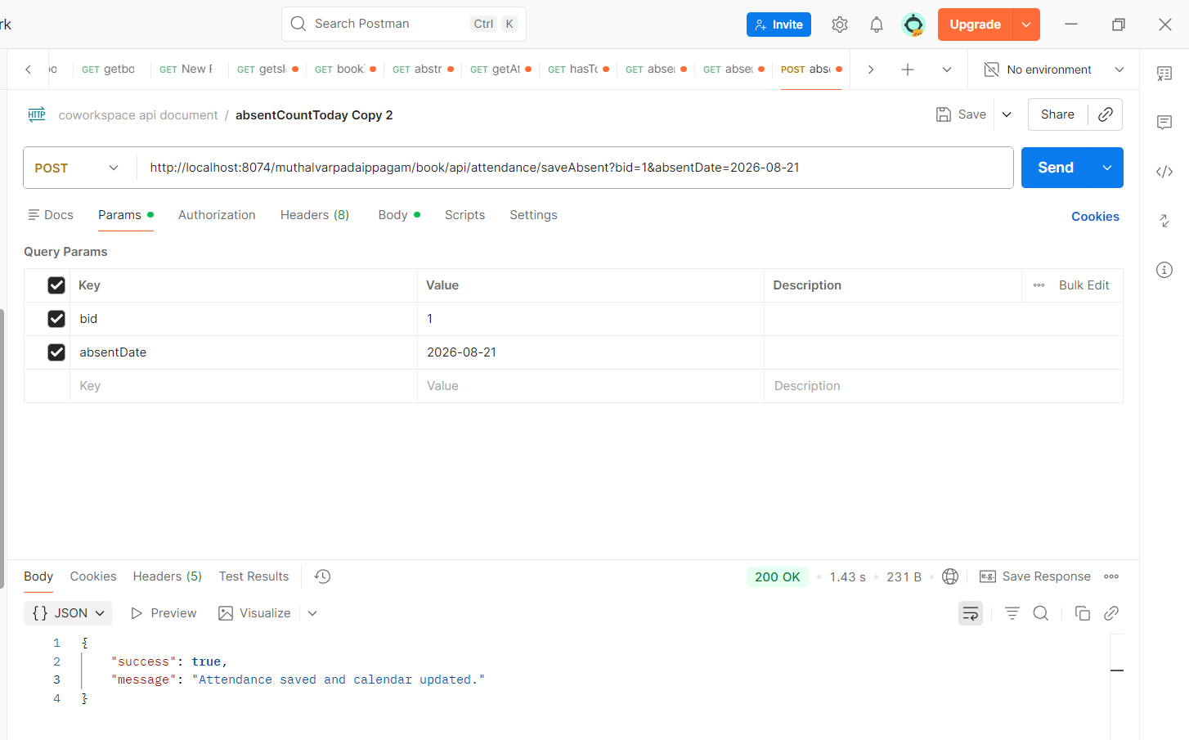
Failure: 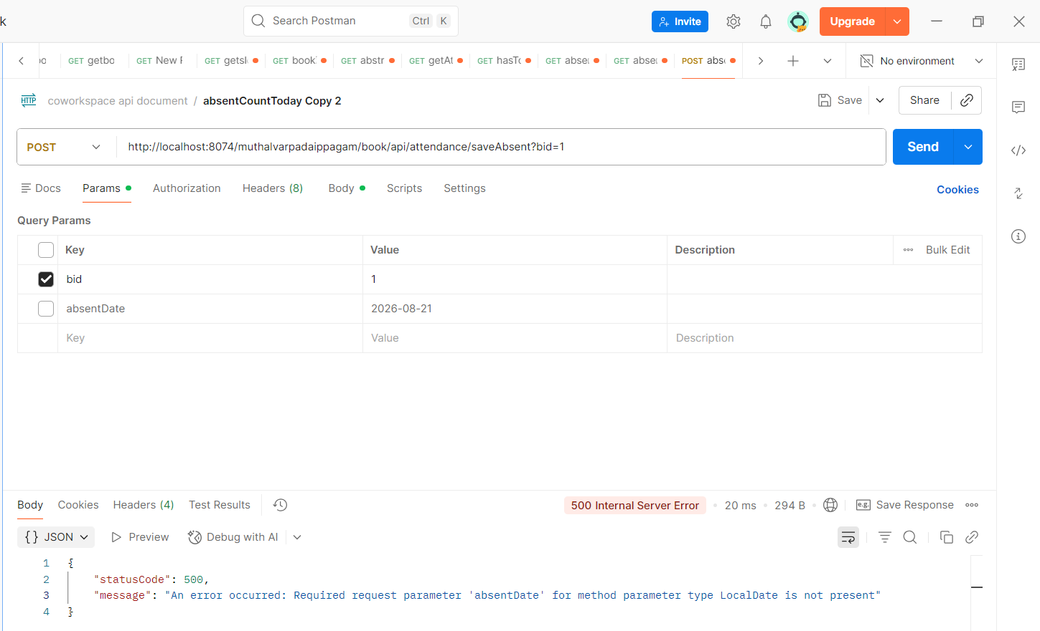
----------------------------------------------------------------------------
Attendance Report
API: /muthalvarpadaippagam/book/api/reports/calendarReport
Method: GET
Table: calendar, booking, category
Parameters:
fromDate → Start date for the report
toDate → End date for the report
bid → Building ID
Purpose:
This API generates the Desk Space attendance summary report for the selected building and date range.
Action:
The API fetches the booking and attendance summary from the calendar table and returns the data grouped by booking date.
The report is restricted to the Desk Space category and only includes active calendar records.
Response Data:
booking_date → Date of the booking/attendance
type → Category type (Desk Space)
total_booked_count → Total number of persons booked for the date
total_absent_count → Total number of absent persons for the date

Screenshot:
Success:
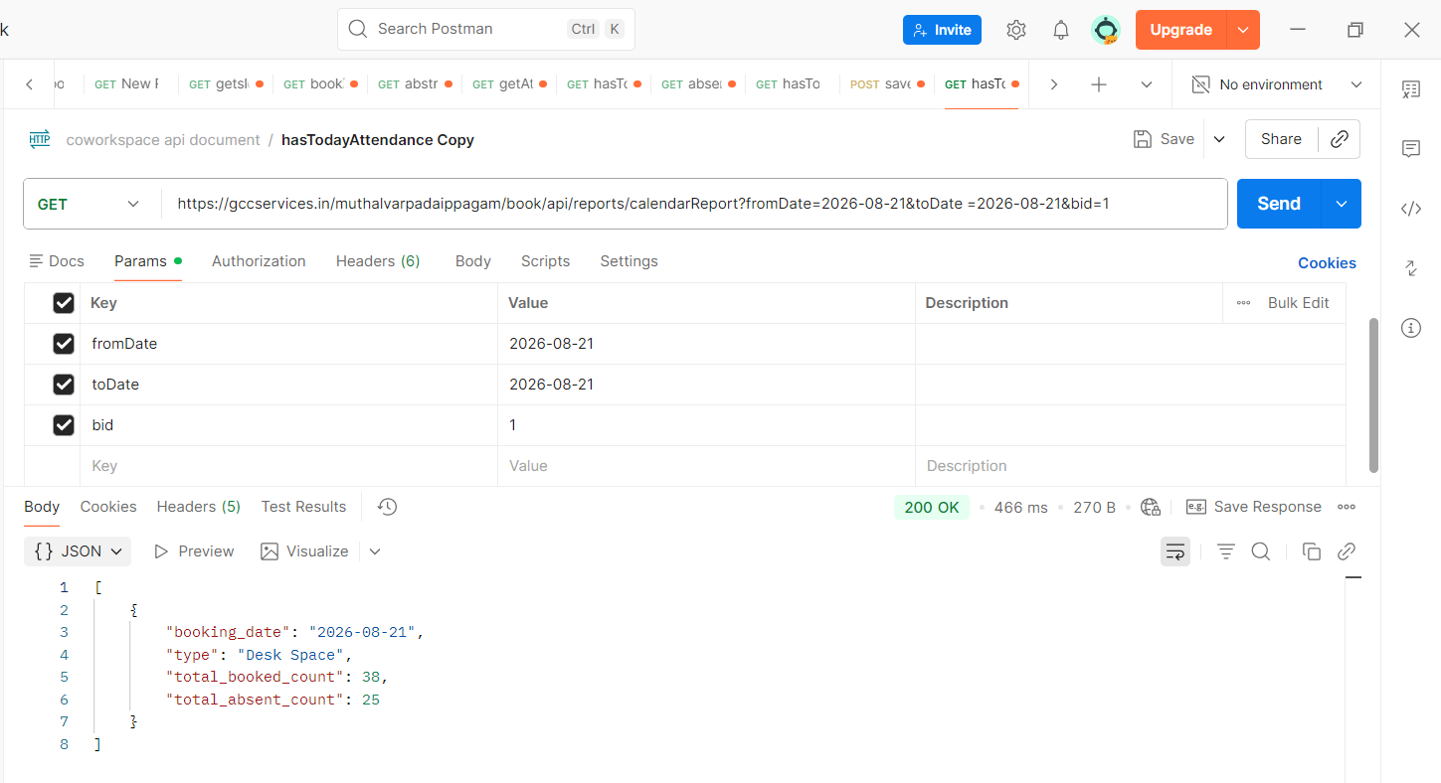

Failure:
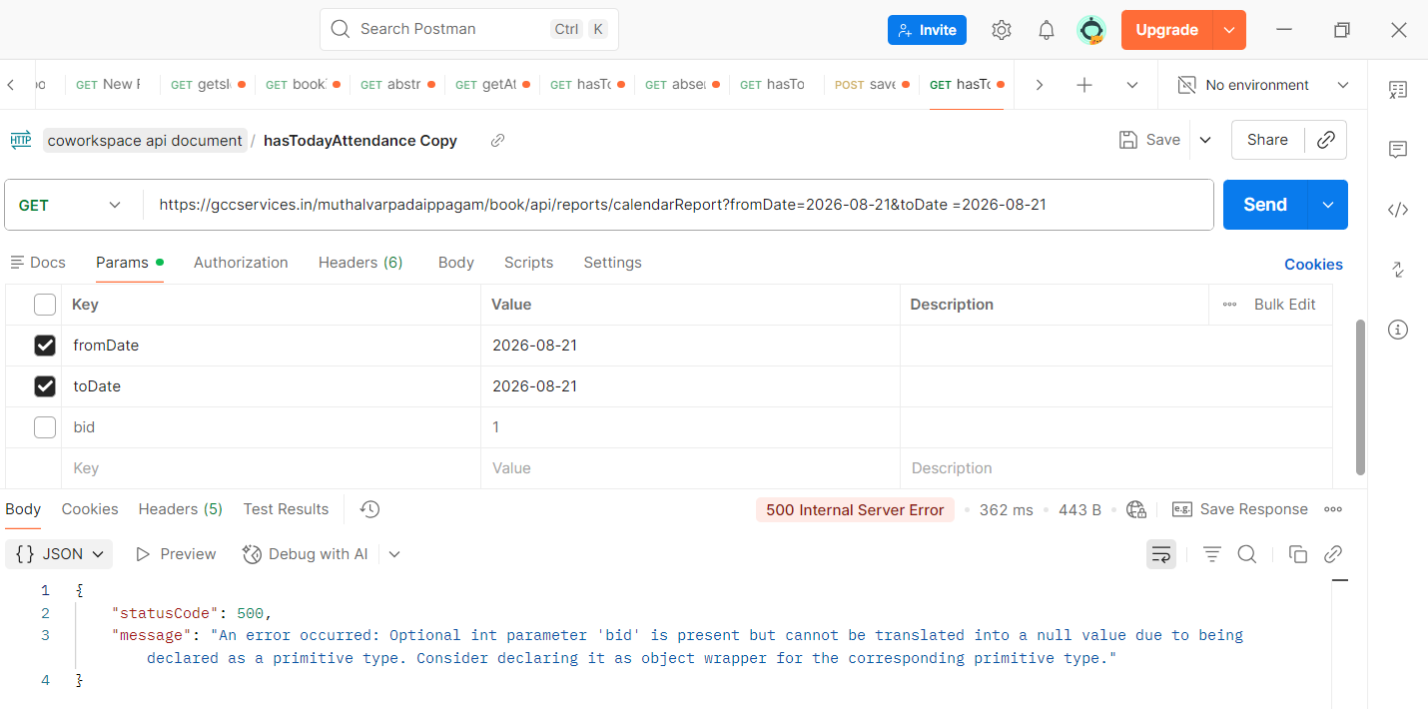
API 1: Booked Details
API: /muthalvarpadaippagam/book/api/attendance/getAttendancereport
Method: GET
Table: booking, calendar, slots, category, subcategory
Parameters:
fromDate → Selected booking date
toDate → Selected booking date
typeName → Category name (Desk Space)
bid → Building ID
Purpose:
This API fetches the booking details for the selected date and building when the user clicks the Booked Count.
Response Data:
bookingid → Booking ID
bid → Building ID
user_name → User name
mobile → User mobile number
type_name → Category name
from_date → Booking start date
to_date → Booking end date
bdate → Booking/slot date
checkin → Check-in time
checkout → Check-out time
no_of_person → Number of booked persons
NoofAbsent → Number of absent persons
amount → Booking amount
Usage:
The returned data is displayed in the Attendance Details modal. It shows all Desk Space booking records for the selected date and calculates the total seats, total absent persons and total amount.
Screenshot:
Success:
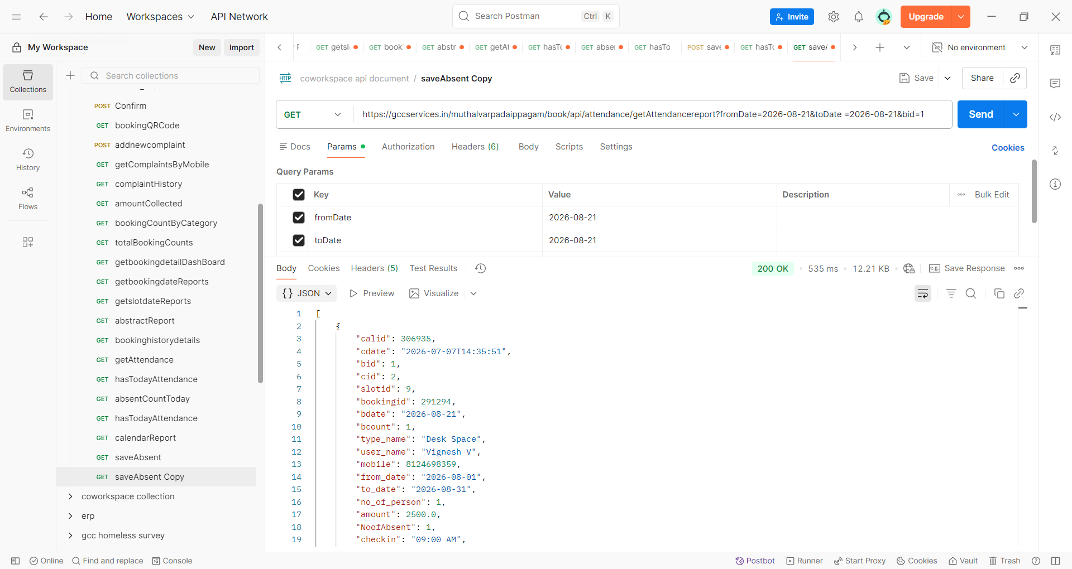

API 2: Absent Details
API: /muthalvarpadaippagam/book/api/attendance/getAttendancereport
Method: GET
Table: booking, calendar, slots, category, subcategory
Parameters:
fromDate → Selected booking date
toDate → Selected booking date
typeName → Category name (Desk Space)
bid → Building ID
Purpose:
This API fetches the attendance details for the selected date and building when the user clicks the Absent Count.
Response Data:
bookingid → Booking ID
bid → Building ID
user_name → User name
mobile → User mobile number
type_name → Category name
from_date → Booking start date
to_date → Booking end date
bdate → Booking/slot date
checkin → Check-in time
checkout → Check-out time
no_of_person → Number of booked persons
NoofAbsent → Number of absent persons
amount → Booking amount
Usage:
The frontend filters the API response and displays only the records where NoofAbsent > 0 in the Absent Details modal.
If no absent records are found, it displays:
No absent records found. All attendees were present!
Note: Both Booked Details and Absent Details use the same API to fetch attendance/booking data.
- Booked Details: Displays all records returned by the API.
- Absent Details: Filters the API response and displays only records where NoofAbsent > 0.
- Therefore, records with NoofAbsent = 0 are not displayed under Absent Details.
- The API itself fetches all the records; the filtering is performed on the frontend.

Daily check list
Checklist Entry

API: /muthalvarpadaippagam/book/api/checklist/questions-options/{shiftId}
Method: GET
Table: question_master, options_values, checklist_feedback
Parameters:
shiftId → Shift ID
Purpose:
This API fetches the checklist questions and their available options for the selected shift.
Action:
The API retrieves the active checklist questions and options for the given shift. It also checks whether the checklist has already been submitted for the current day.
For each question, the API identifies whether an option was previously selected and returns the selected option along with the question details.
Shift Details:
shiftId = 1 → Day Working
shiftId = 2 → Second Shift
shiftId = 3 → 15 Days Once Deep Cleaning
The Deep Cleaning checklist is available only on the 15th day and the last day of the month. On other days, no questions are returned and the Deep Cleaning tab is disabled.
Response Data:
id → Question ID
questions → Checklist question
field_name → Field name used for the selected answer
options → Available options for the question
options.id → Option ID
options.options → Option text
options.selected → Indicates whether the option was previously selected
submitted → Indicates whether the checklist has already been submitted for today
Usage:
The frontend calls this API when the Checklist page is loaded and whenever the user switches between the checklist tabs.
The returned questions and options are displayed as radio-button questions.
Screenshot:
Success:
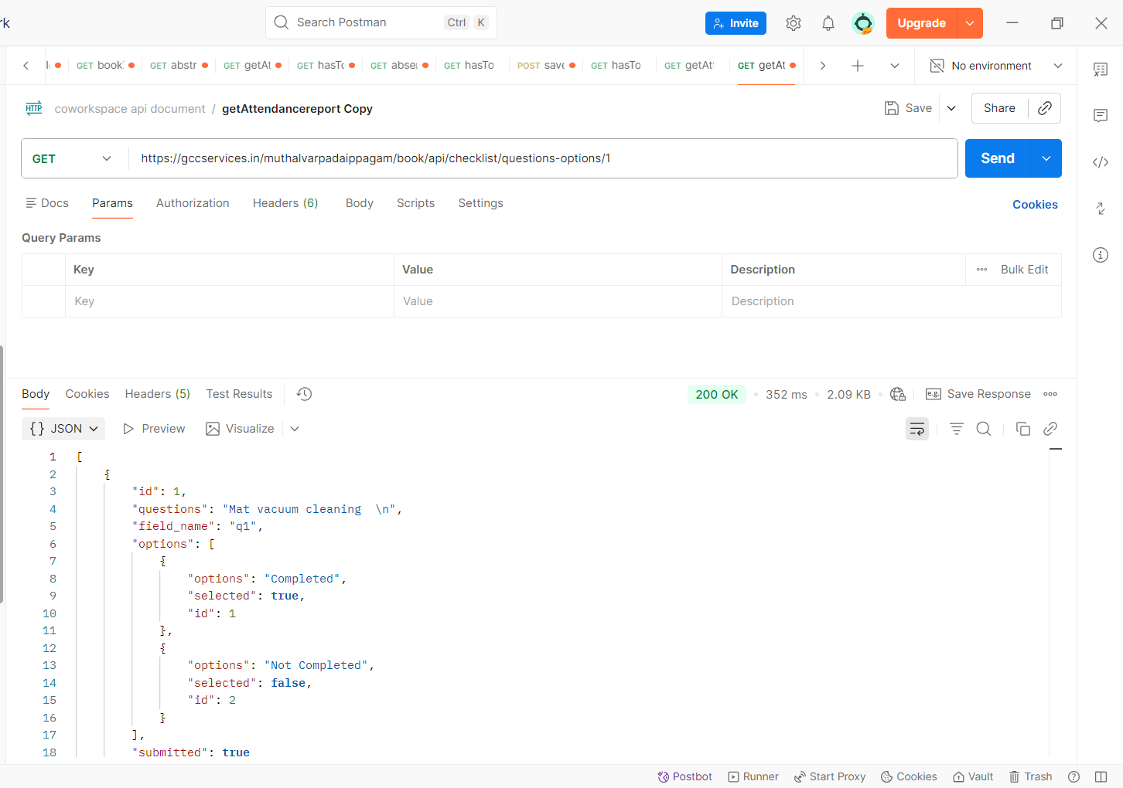
Failure:
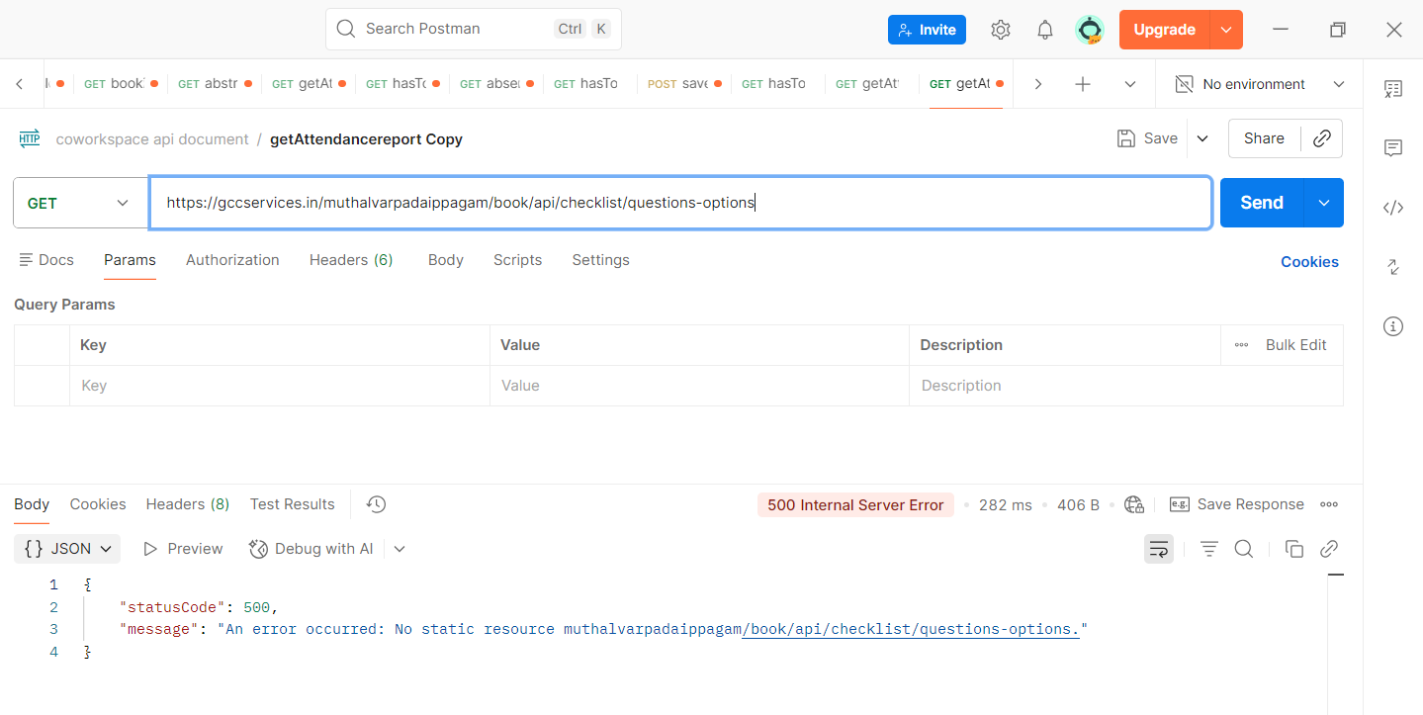
API: Submit Checklist Feedback
API: /muthalvarpadaippagam/book/api/checklist/submit-feedback
Method: POST
Table: checklist_feedback
Parameters:
shiftId → Shift ID of the checklist
date → Server date on which the checklist is submitted
answers → Selected answers for each checklist question
Purpose:
This API saves the checklist responses submitted by the user for the selected shift and date.
Request Data:
shiftId → Shift ID
date → Submission date
answers → Selected option for each question
The answers object contains the question field name and the selected option ID.
Example Request:
{
"shiftId": 1,
"date": "2026-08-19",
"answers": {
"q1": "1",
"q2": "2",
"q3": "1"
}
}
Action:
The API dynamically creates the INSERT query based on the submitted answers and stores:
- shift_id
- cdate
- Selected answer for each checklist question
in the checklist_feedback table.
Usage:
The frontend calls this API when the user clicks the Submit button on the checklist form. The selected radio-button values are collected and sent to the API.
After successful submission:
- Submit button is disabled.
- Button text changes to Submitted.
- All radio buttons are disabled.
- The corresponding shift tab changes from red to green.
- A success message is displayed: "Your checking has been submitted successfully."
Screenshot:
Success:
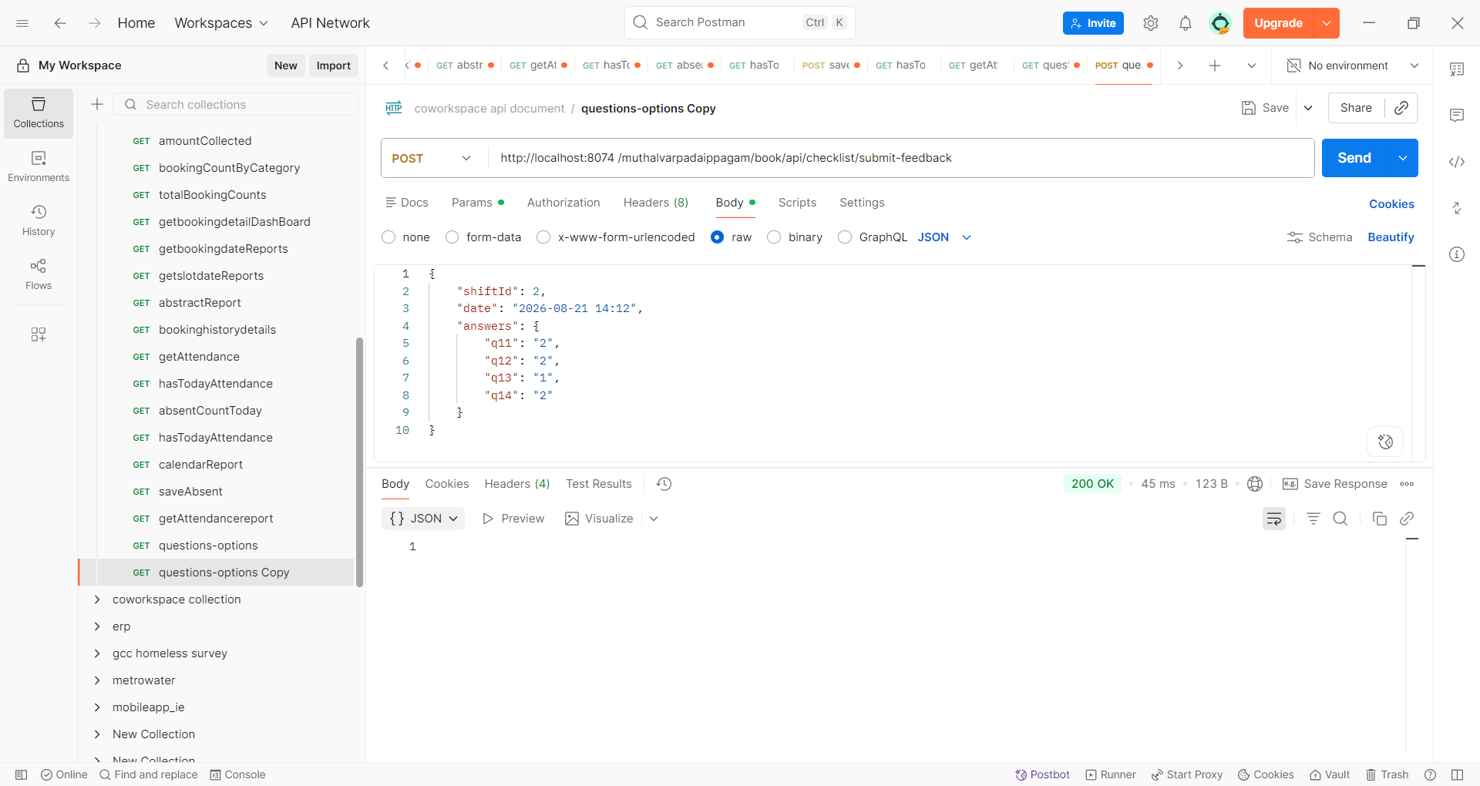

Note: it is not returning any if status code is 200 means it is inserted

Checkilist report
API: /muthalvarpadaippagam/book/api/checklist/report?from={from}&to={to}
Method: GET
Table: checklist_feedback
Parameters:
from → Start date for the report
to → End date for the report
Purpose:
This API generates a Checklist Feedback Summary Report for the selected date range.
Action:
The API checks the checklist_feedback table and identifies which shifts have submitted their checklist for each date within the selected date range.
The report checks the following shifts:
Shift 1 → First Shift
Shift 2 → Second Shift
Shift 3 → Deep Cleaning
Response Data:
date → Checklist submission date
shift1 → Indicates whether Shift 1 checklist was submitted
shift2 → Indicates whether Shift 2 checklist was submitted
shift3 → Indicates whether Shift 3 checklist was submitted
Response Example:
[
{
"date": "2026-08-19",
"shift1": true,
"shift2": true,
"shift3": false
}
]
true → Checklist submitted for that shift.
false → Checklist not submitted for that shift.
Usage:
The frontend calls this API when the user selects the From Date and To Date in the Checklist Report page.
The response is displayed in the report table as:
Date | Shift 1 | Shift 2 | Shift 3
A check mark (✅) is displayed when the checklist has been submitted. If it has not been submitted, - is displayed.
The user can click the check mark to open the submitted checklist details for the selected shift and date.

Screenshot:
Success 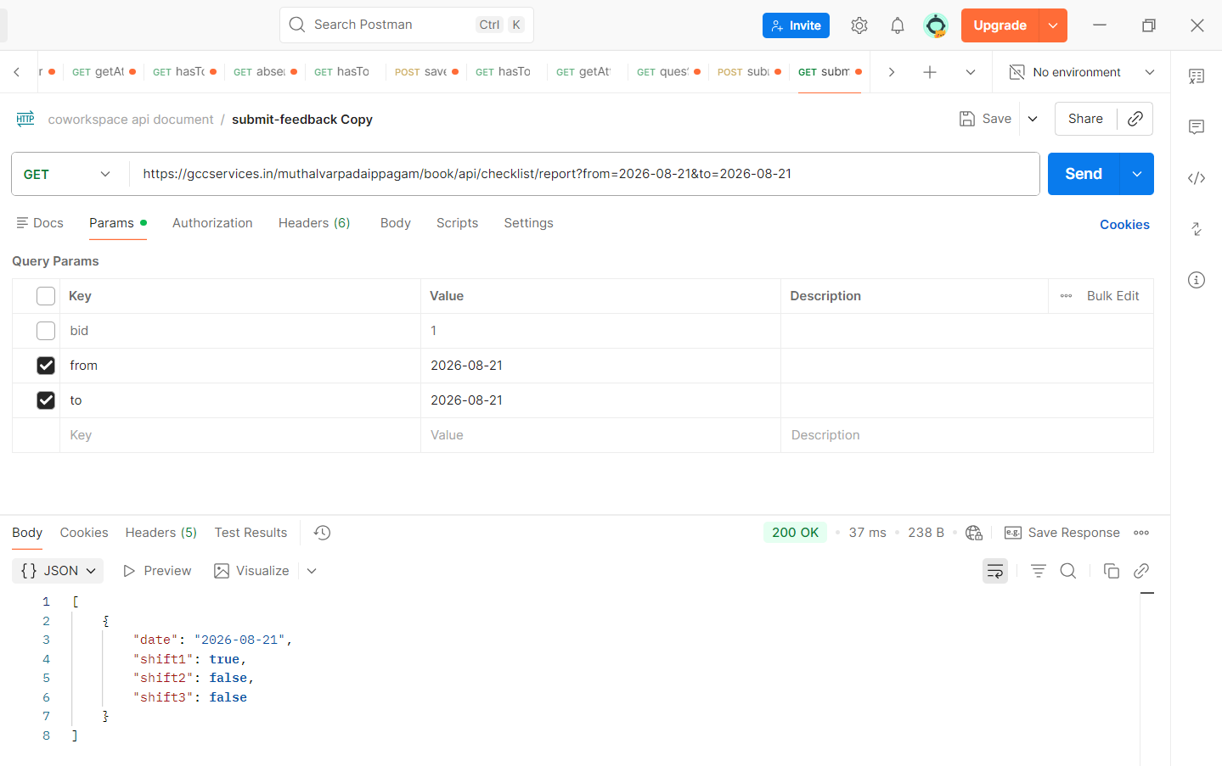
Failure:
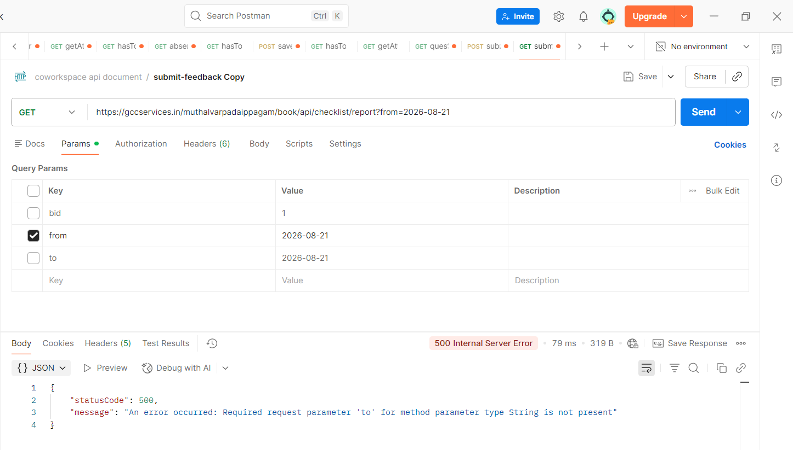

API: /muthalvarpadaippagam/book/api/checklist/reportfeedback/{shiftId}&{date}
Method: GET
Table: question_master, options_values, checklist_feedback
Parameters:
shiftId → Shift ID
date → Checklist submission date
Purpose:
This API fetches the submitted checklist questions, available options and the selected answers for a specific shift and date.
Action:
The API retrieves the active questions and options for the selected shift and checks the checklist_feedback table for the submitted feedback on the selected date.
It identifies the previously selected option for each question and marks it as selected.
For shiftId = 3, the API allows the Deep Cleaning checklist only on the 15th day or the last day of the month.
Response Data:
id → Question ID
questions → Checklist question
field_name → Question field name
options → Available options
options.id → Option ID
options.options → Option text
options.selected → Indicates the selected option
submitted → Indicates whether feedback was submitted for the selected date and shift
Usage:
The frontend calls this API when the user clicks the check mark (✅) for a particular shift in the Checklist Report.
The returned questions and options are displayed in a Feedback Details modal.
The previously selected answers are displayed as selected radio buttons, and all options are disabled because this is a submitted feedback report.
The modal also provides a Print option to print the submitted checklist.
Screenshot:
Success:
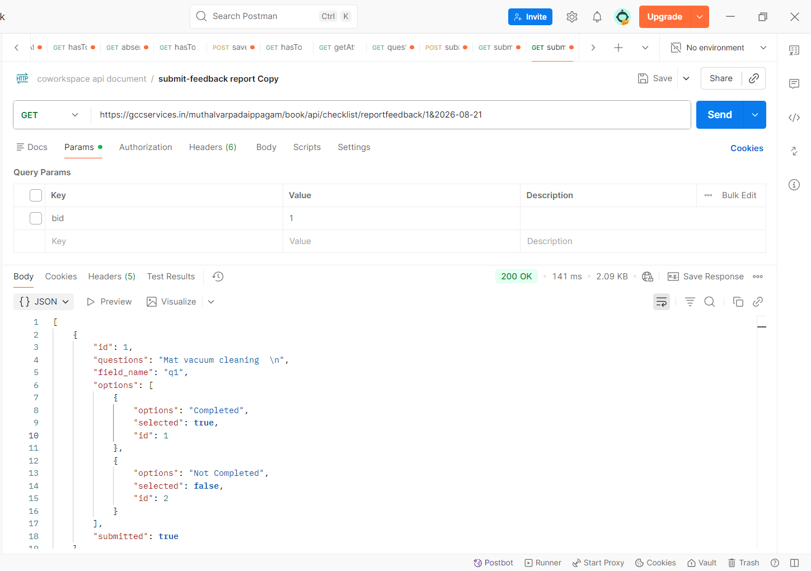

Failure:
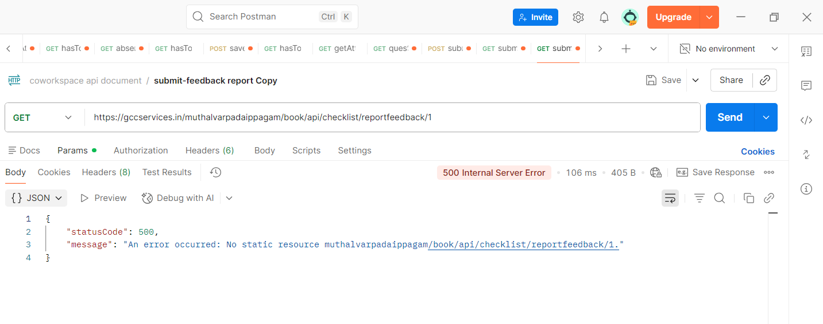

Compliant list

API: /muthalvarpadaippagam/complaint/api/complaintlist
Method: GET
Table: complaint_details
Purpose:
This page fetches and displays the complaint details for the caretaker, separated into Open Complaints and Closed Complaints.
Action:
The controller checks whether the caretaker is logged in and then retrieves:
- Open complaints → status = 'OPEN'
- Closed complaints → status = 'CLOSED'
The complaint image path is also converted into a complete image URL before displaying it.
Response Data:
complaint_no → Complaint number
user_name → User name
mobile_number → User mobile number
remarks → Complaint remarks
upload_photo_url → Uploaded complaint photo
cdate → Complaint created date
status → Complaint status
Usage:
The complaint list is displayed in two sections:
Open Complaints
Displays complaints whose status is OPEN. The caretaker can click the Action button to view the complaint details and provide caretaker remarks and an optional photo.
Closed Complaints
Displays complaints whose status is CLOSED. These complaints are shown for reference and the action for closing the complaint is disabled.

API: /muthalvarpadaippagam/complaint/api/complaintHistory
Method: GET
Table: complaint_details_history
Parameters:
complaintNo → Complaint number
Purpose:
This API fetches the complete history of a complaint based on the complaint number.
Response Data:
complaint_no → Complaint number
cdate → Complaint created date
caretaker_updated_date → Caretaker update date
user_name → User name
remarks → Complaint remarks
upload_photo_url → User uploaded complaint photo
caretaker_remarks → Caretaker remarks
caretaker_photo_url → Caretaker uploaded photo
Usage:
The frontend calls this API when the user clicks the Complaint Status.
The returned complaint history is displayed in the Complaint History modal.
The modal displays the complaint details including user remarks, user uploaded photo, caretaker remarks, caretaker photo and caretaker updated date.
The photo paths returned from the database are converted into the required document URL before displaying the images.
Screenshot:
Success:
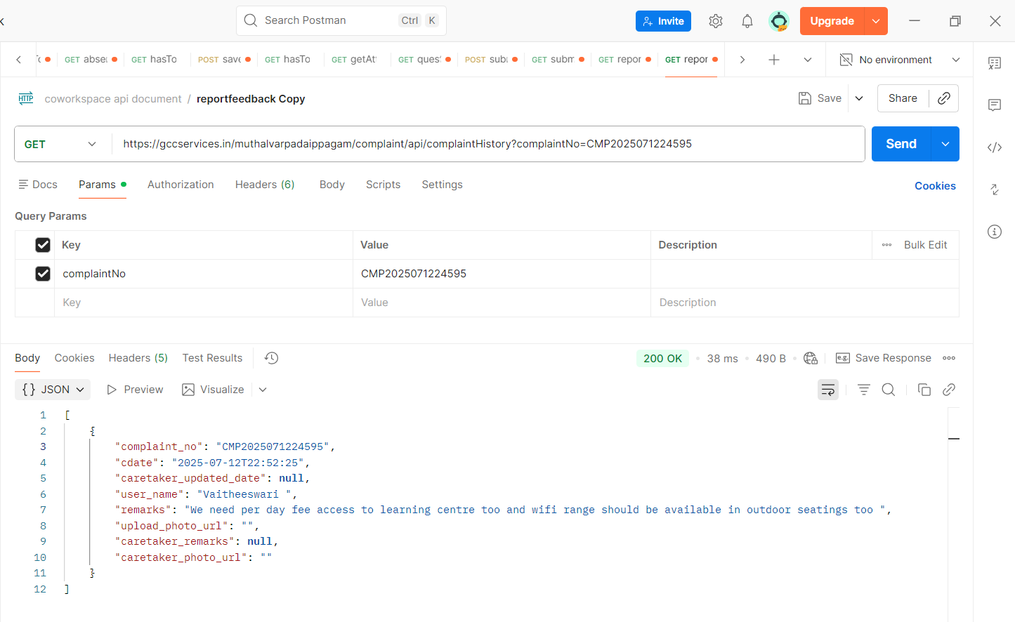

Failure:
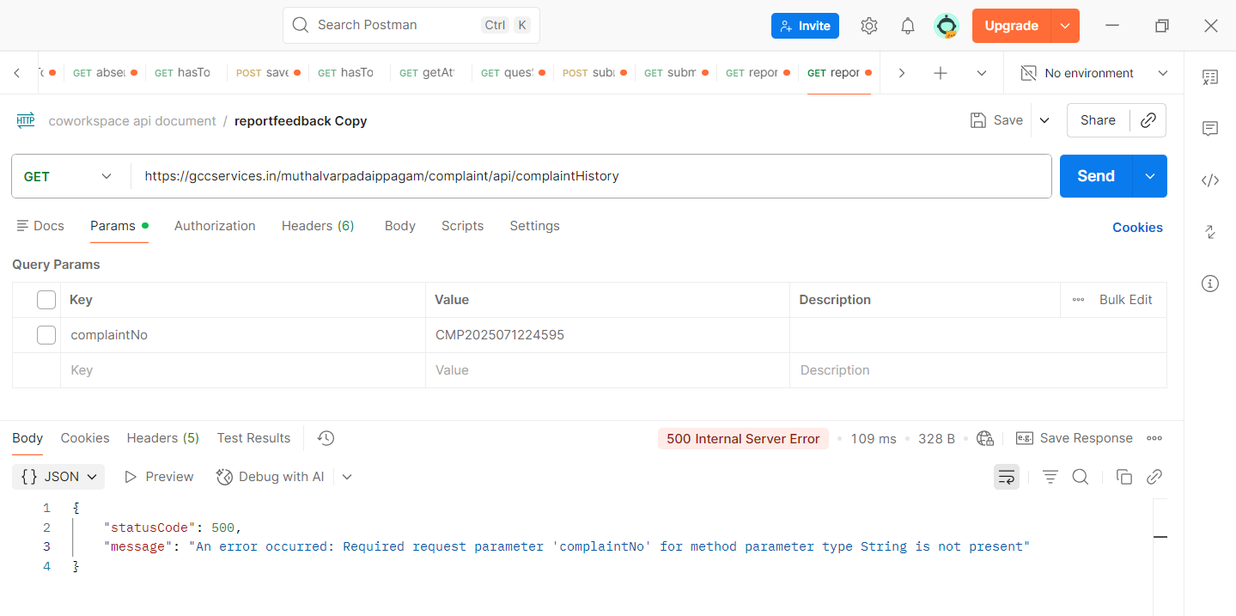

API: /muthalvarpadaippagam/complaint/api/updateCaretakerRemarks
Method: POST
Table: complaint_details, complaint_details_history
Parameters:
id → Complaint ID / Complaint number
caretakerRemarks → Remarks entered by the caretaker
uploadPhotoUrlcaretaker → Caretaker uploaded photo (optional)
Purpose:
This API updates the caretaker remarks and caretaker photo for a complaint and closes the complaint.
Action:
The API receives the caretaker remarks and optional photo, updates the complaint status to CLOSED, and records the caretaker update in the complaint history.
The updated complaint details are also inserted as a new record in the complaint_details_history table for maintaining the complaint history.
Response:
The API returns a successful response after the caretaker details are updated.
Usage:
The frontend calls this API when the caretaker clicks the Submit button after entering the caretaker remarks.
Caretaker remarks are mandatory. The caretaker photo is optional.
After successful submission:
- Complaint status is changed to CLOSED
- Caretaker remarks are saved
- Caretaker photo is saved if uploaded
- Caretaker updated date is recorded
- Complaint history is updated

Screenshot:
Success:
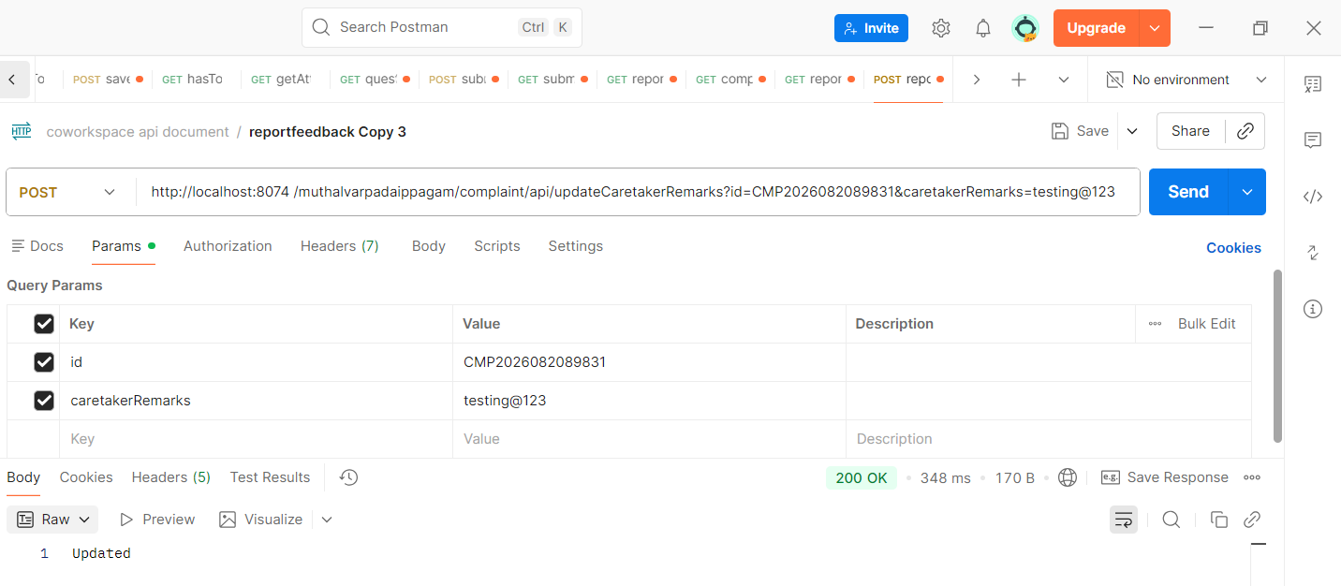
Failure:
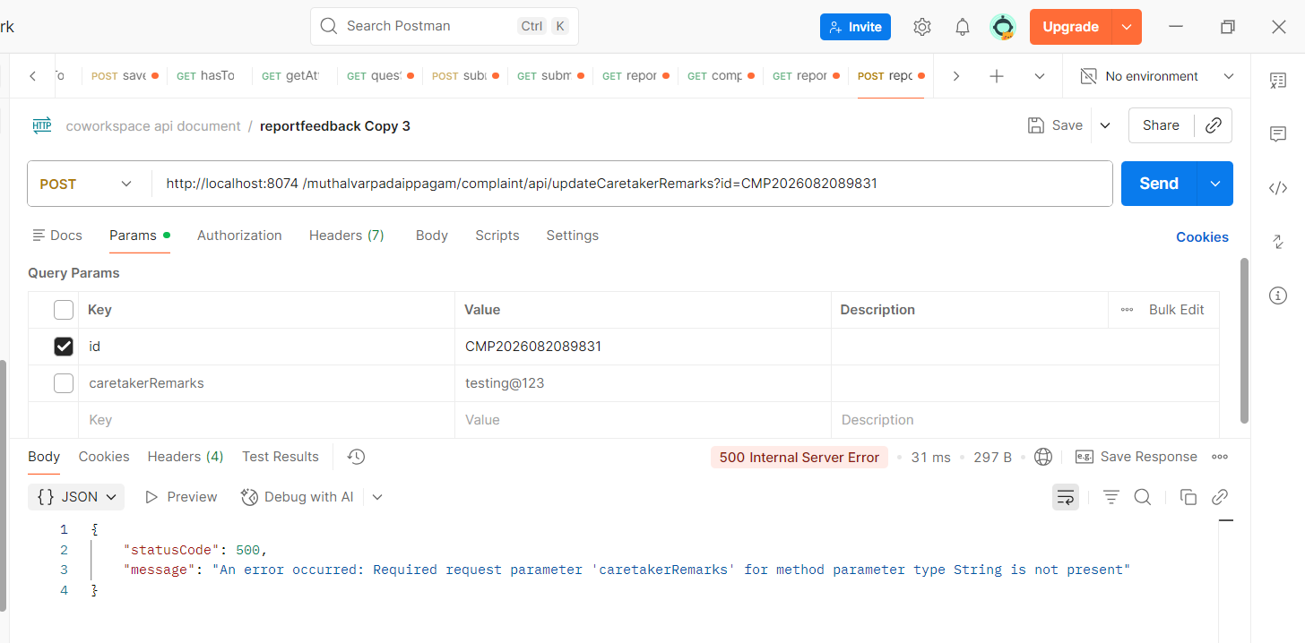

Main controller
API: /muthalvarpadaippagam/workspacelist
Method: GET
Purpose:
This controller loads and returns the Workspace List page.
Note: model.addAttribute("buildings", buildingList);
model.addAttribute("spaces", spaces);
Controller: /home
1. GET Mapping
API: /muthalvarpadaippagam/home
Method: GET
Parameters:
- bid → Building ID (mandatory)
- cid → Category ID (optional)
Purpose:
This endpoint loads the Home page for the selected building and category.
Action:
- Checks whether bid is provided.
- If bid is not provided, the user is redirected to /muthalvarpadaippagam.
- If bid is available, the controller calls the common loadHomePage() method.
- The loadHomePage() method loads the required category, pricing and image details for the selected building.
Response:
Returns the Thymeleaf page:
user/home

2. POST Mapping
API: /muthalvarpadaippagam/home
Method: POST
Parameters:
- bid → Building ID (mandatory)
- cid → Category ID (optional)
Purpose:
This endpoint loads the same Home page through a POST request.
Action:
- Receives the bid and optional cid as POST parameters.
- Calls the common loadHomePage() method.
- The same page data is loaded as in the GET mapping.
Response:
Returns the Thymeleaf page:
user/home

Why are GET and POST used for the same page?
Both endpoints are used to open the same Home page, but they support different navigation requirements.
GET /home is used when the Home page is accessed directly with the building and category IDs in the URL.
Example:
/muthalvarpadaippagam/home?bid=1&cid=2
In this case, bid and cid are visible in the browser URL.
POST /home is used when the user navigates from the Workspace List page through a form submission.
The bid and cid are submitted as POST parameters instead of URL parameters.
Main reason for using POST:
The application uses POST navigation to hide the bid and cid values from the browser URL.

API: /muthalvarpadaippagam/home
Method: GET
Parameters:
- bid → Building ID (mandatory)
- cid → Category ID (optional)
Purpose:
Loads the Home page based on the selected building and category.
Action:
- Validates the bid.
- Calls the common loadHomePage() method.
- The loadHomePage() method retrieves the active coworking spaces available for the selected building.
- The retrieved category information is used to determine the selected workspace and display the corresponding Home page content.
Response:
Returns the Thymeleaf page:
user/home

API: /muthalvarpadaippagam/home
Method: POST
Parameters:
- bid → Building ID (mandatory)
- cid → Category ID (optional)
Purpose:
Loads the same Home page using a POST request.
Action:
- Receives the building ID and optional category ID through POST parameters.
- Calls the common loadHomePage() method.
- The same Home page is returned.
Why POST is used for the same page:
The POST mapping is used when navigating to the Home page through a form submission so that the bid and cid values are not exposed in the browser URL.
Therefore:
- GET → Parameters can appear in the URL.
- POST → Parameters are submitted in the request body/form data and are not displayed in the URL.
Both mappings use the same loadHomePage() method to avoid duplicate page-loading logic.

Common Method: loadHomePage()
Method: loadHomePage(int bid, Integer cidParam, Model model)
Purpose:
Prepares the data required to display the Home page for the selected building and category.
Action:
- Calls getActiveCoWorkingSpacesByBuilding(bid) to retrieve the active coworking categories for the selected building.
- Removes duplicate category IDs from the returned list.
- Determines the selected category ID:
  - Uses the supplied cid if available.
  - Otherwise, selects the first available category.
- Retrieves pricing details for the selected category.
- Retrieves category images using getImgByCid(cid).
- Determines the selected workspace/category.

GET Endpoint
API: /muthalvarpadaippagam/book
Method: GET
Parameters:
buildingId → Building ID
categoryId → Category ID
subId → Subcategory ID (optional)
Purpose:
This endpoint loads the booking page for the selected building, category, and subcategory.
Action:
The endpoint first validates that buildingId and categoryId are available. It then verifies that the selected category and subcategory belong to the selected building using checkbuildingbycat().
If the validation fails, the user is redirected to the main page.
If validation is successful, the endpoint calls the common showCategoryPage() method to load the booking page.
Validation:
- buildingId is mandatory.
- categoryId is mandatory.
- subId is validated against the selected category and building.
- The category and subcategory must be active and not deleted.

POST Endpoint
API: /muthalvarpadaippagam/book
Method: POST
Parameters:
buildingId → Building ID
categoryId → Category ID
subId → Subcategory ID (optional)
Purpose:
This endpoint loads the same booking page through a POST request.
Why GET and POST are used for the same page:
Both endpoints load the same booking page, but they support different navigation requirements.
- GET is used when the booking page is opened with parameters visible in the URL.
- POST is used when the application submits a hidden form and the parameters should not be exposed in the URL.
- Both methods finally call the same showCategoryPage() method, so the page-loading logic is maintained in one place.
This avoids duplicating the booking-page loading logic.

Common Method: showCategoryPage()
Purpose:
This method contains the common logic used by both GET and POST endpoints to prepare and display the booking page.
Action:
- Fetches building and category details using buildingId and categoryId.
- Fetches category images using getImgByCid(categoryId).
- Gets the category display name.
- Adds building information to the model.
- Gets the subcategory ID from the database if subId was not provided.
- Adds buildingId, categoryId, and subId to the model.
- Determines which booking page should be displayed based on the category name.

API: /muthalvarpadaippagam/bookinghistory
Method: GET
Table: booking
Purpose:
This controller loads the Booking History page for the currently logged-in user.
Action:
The controller checks whether the userSession is available and whether the user's mobile number is valid.
If the session is available, it calls:
bookingService.getBookingByMobileNo(userSession.getMobileno())
The booking details returned from the service are added to the model as bookinghistorylist.
Model Data:
bookinghistorylist → Contains the booking history of the logged-in user.
Usage:
This controller is called when the user opens the Booking History page.
The returned data is passed to the user/bookinghistory Thymeleaf page and displayed to the user.
Response / View:
user/bookinghistory

API: /muthalvarpadaippagam/registercomplaint
Method: GET
Purpose:
This controller loads the Register Complaint page.
Action:
When the user accesses this endpoint, the controller directly returns the complaint registration page.
Usage:
This endpoint is used to open the Register Complaint page where the user can enter and submit a new complaint.
---------------------------
API: /muthalvarpadaippagam/officiallogin
Method: GET
Purpose:
This controller loads the Caretaker Login page.
Action:
It returns the caretaker login page.
Usage:
This endpoint is used when an official/caretaker accesses the login page.
-----------------------------------
API: /muthalvarpadaippagam/logout
Method: GET
Purpose:
This controller logs out the currently logged-in official/caretaker user and redirects them to the official login page.
Action:
The controller first sets No-Cache HTTP headers using setNoCacheHeaders(response).
It then invalidates the current HttpSession using:
session.invalidate()
This removes the user's active session and clears the session-based login information.
After successfully invalidating the session, the user is redirected to the official login page.
If any exception occurs during logout, the controller also redirects the user to the official login page.
API: /muthalvarpadaippagam/Dashboard
Method: GET
Purpose:
This controller loads the Caretaker Dashboard for the logged-in user.
Action:
The controller retrieves the following details from the current HttpSession:
- user_name → Logged-in official/caretaker username
- bid → Building ID assigned to the logged-in user
The controller checks whether both user_name and bid are available in the session.
If both values are available:
- user_name is added to the model.
- bid is added to the model.
- The caretaker dashboard page is returned.
If either user_name or bid is missing, the user is redirected to the Official Login page.
Usage:
This endpoint is used when an official/caretaker accesses the Dashboard after logging in.
The bid stored in the session is passed to the dashboard so that dashboard data can be loaded for the respective building
API: /muthalvarpadaippagam/Report
Method: GET
Purpose:
This controller loads the Caretaker Report page for the logged-in user.
Action:
The controller retrieves the following details from the current HttpSession:
- user_name → Logged-in official/caretaker username
- bid → Building ID assigned to the logged-in user
The controller checks whether:
- user_name is available and not empty.
- bid is available in the session.
If both values are available, they are added to the model and the report page is displayed.
If the user is not logged in or the bid is not available, the user is redirected to the Official Login page.
API: /muthalvarpadaippagam/Abstract
Method: GET
Table: None
Purpose:
This controller loads the Abstract Report page for the logged-in caretaker user.
Action:
The controller retrieves the following details from the current HttpSession:
- user_name → Logged-in official/caretaker username
- bid → Building ID assigned to the logged-in user
The controller checks whether user_name is available and not empty.
If the user is logged in:
- user_name is added to the model.
- bid is added to the model.
- The Abstract Report page is returned.
If user_name is not available, the user is redirected to the Official Login page.
API: /muthalvarpadaippagam/bookingdetails
Method: GET
Table: login
Purpose:
This controller loads the Booking Details page for the logged-in official/caretaker user.
Action:
The controller first applies No-Cache HTTP headers using setNoCacheHeaders(response).
It then retrieves the user_name from the current HttpSession.
If the user_name is available:
- The controller calls bookingService.getBidByUserName(userName) to retrieve the building ID associated with the logged-in user.
- user_name is added to the model.
- bid is added to the model.
- The retrieved bid is also stored in the session for later use.
- The Booking Details page is returned.
API: /muthalvarpadaippagam/attendance
Method: GET
Purpose:
This controller loads the Attendance page for the logged-in official/caretaker user.
Action:
The controller retrieves the following details from the current HttpSession:
- user_name → Logged-in official/caretaker username
- bid → Building ID assigned to the logged-in user
The controller checks whether user_name is available and not empty.
If the user is logged in:
- user_name is added to the model.
- bid is added to the model.
- The Attendance page is returned.
If user_name is not available, the user is redirected to the Official Login page.
API: /muthalvarpadaippagam/attendancereport
Method: GET
Table: None
Purpose:
This controller loads the Attendance Report page for the logged-in official/caretaker user.
Action:
The controller retrieves the following details from the current HttpSession:
- user_name → Logged-in official/caretaker username
- bid → Building ID assigned to the logged-in user
The controller checks whether user_name is available and not empty.
If the user is logged in:
- user_name is added to the model.
- bid is added to the model.
- The Attendance Report page is returned.
If user_name is not available, the user is redirected to the Official Login page.
API: /muthalvarpadaippagam/complaintlist
Method: GET
Table: complaint_details
Purpose:
This controller loads the Complaint List page for the logged-in official/caretaker and displays both Open Complaints and Closed Complaints.
Action:
The controller retrieves the user_name from the current session and verifies whether the official/caretaker is logged in.
If the user is logged in, the controller:
- Fetches all complaints with status OPEN.
- Fetches all complaints with status CLOSED.
- Builds the complete URL for the user-uploaded complaint photos.
- Adds the complaint lists and username to the model.
- Returns the Complaint List page.
If the user is not logged in, the controller redirects to the Official Login page.
API: /muthalvarpadaippagam/CheckList
Method: GET
Purpose:
This controller loads the Checklist page for the logged-in official/caretaker user.
Action:
The controller retrieves the user_name from the current HttpSession and checks whether the user is logged in.
If the user is logged in:
- user_name is added to the model.
- The current server date and time are generated.
- The server date and time are added to the model as serverDate.
- The Checklist page is returned.
If the user is not logged in, the user is redirected to the Official Login page.
API: /muthalvarpadaippagam/CheckListReport
Method: GET
Purpose:
This controller loads the Checklist Report page for the logged-in official/caretaker user.
Action:
The controller retrieves the user_name from the current HttpSession and checks whether the user is logged in.
If the user is logged in:
- user_name is added to the model.
- The Checklist Report page is returned.
If the user is not logged in, the user is redirected to the Official Login page.

